User guide to application configuration

DData#HRMS Creatio

DData Consulting
Content
System Login 4
DDATA # HRMS Initial setup 5
Workplace and its change 5
Adjustment of work schedules 6
How to generate a department in the organizational structure of the company 7
How to generate a position in the organizational structure of the company 9
How to generate a position through the section [Departments] 10
How to add functional responsibilities to the system 11
How to add skills and scope of competence to the system 13
How to specify functional responsibilities of a position 14
How to indicate level of skills and scope of competence required for a position 15
How to generate a contact/employee 16
How to link an "Employee" contact type to a position 17
Case work description "Employees Positions/Basic" 18
Management of vacancies and interviews 20
How togenerate a vacancy 20
How to specify vacancy functional responsibilities 21
How to specify required skills and scope of competence for a vacancy 21
How to generate a job interview 22
How to add an interview comment 23
How to indicate the candidate's current level of skills and scope of competence 24
Onboarding 28
How to add adaptation status 28
Adding activity by stage of Onboarding 29
How to add Onboarding to an employee 31
Offboarding 32
How to add offboarding status 32
Adding activity to offboarding stage 32
How to add offboarding to an employee 34
KPI management 35
How to add KPI measurements to the system 35
How to generate a KPI setting template 36
How to add a measurement to a template 37
How to generate a KPI for a department or employee 37
Case work description "KPI/ Basic " 39
Knowledge base 40

System Login
DData HRMS Creatio product is a web resource, therefore follow the respective link to launch the system. SYSTEM LOGIN window will open. Login to the system using your personal Login and Password.
To log in:
- Enter Login and Password in respective fields:
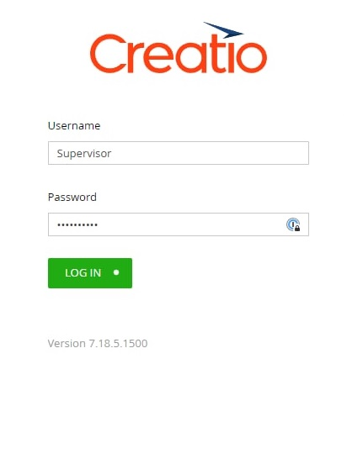
- Click [Login].
Login to DData HRMS Creatio is completed.

DDATA # HRMS Initial setup
For fully functional use of DDATA HRMS system, a Company's organizational structure should be fill out beforehand.
All registers of sections have the same functionality. Upon selection of a specific entry in the registry, a toolbar will appear. With its help open, copy or delete the selected entry.
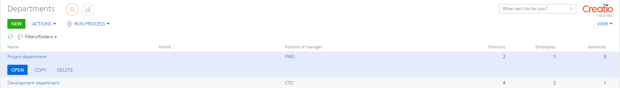
Use data import for quick and massive fill out of DDATA HRMS Creatio system. Import data from Excel before you start using DDATA HRMS Creatio or when you need to add new entries to the system. Also, use to update and supplement existing entries. Follow the link to Creatio portal to find the detailed import instructions: https://academy.terrasoft.ua/documents/base/7-16/import-dannyh-iz-excel?document=studio
WARNING! Import of entries is available in accordance with settings of roles and access rights.

Workplace and its change
The workplace and sections are located on the sidebar (sections bar) placed on the left side of the screen. The current workplace is displayed under the buttons for quick access to the main system operations. Use a drop-down list to switch between User’s workplaces. Click to select the workplace you need.
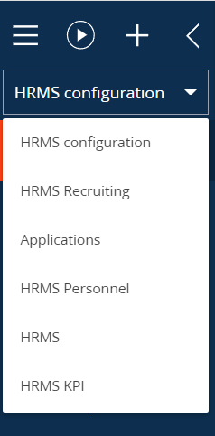

Adjustment of work schedules
Contains records of the company's work schedules.
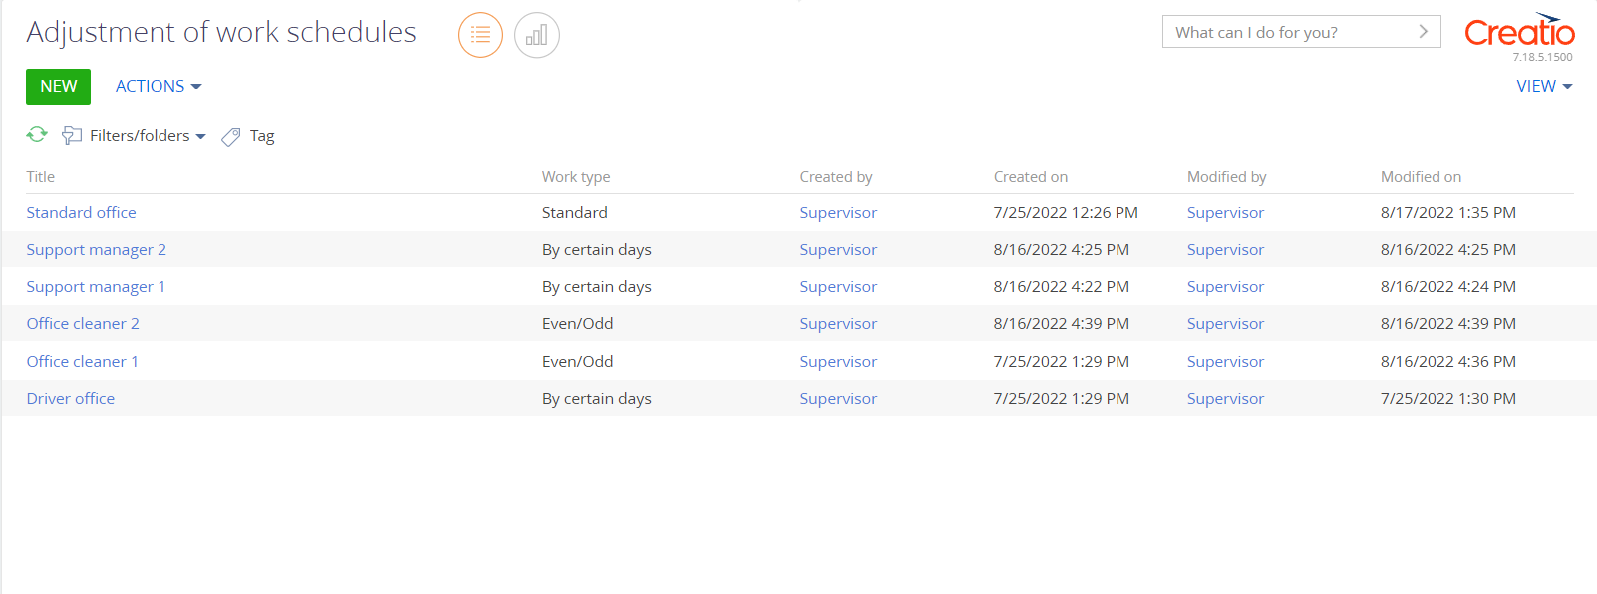
Follow the steps below to add work schedules:
- Open workplace [HRMS settings]
- Go to section [Adjustment of work schedules]
- Click [Add]
- Fill in the following mandatory fields of the opened mini-card:
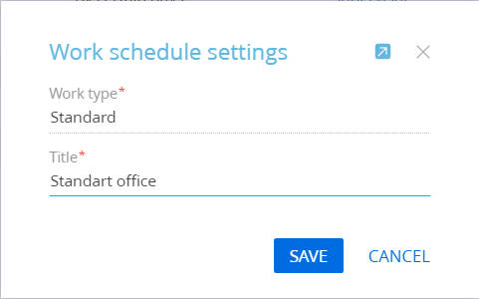
- [Work type] - Click , and select the required work type from the directory. Choose one of the options: variable; standard; on certain days; even/odd.
- [Title] – text field for entering a user-defined title. It is recommended to title the position to which it will apply in accordance with the type and schedule of work.
- Click [Save] to generate a new entry
- To continue working with the entry of a new work schedule, click on the title of the generated entry. A full card for detailed setting of the work schedule will open.

- Fill out the following fields for configuration:
- [Starting time] - click to open the drop-down list. Select the time when the work shift begins
- [Ending time] - click to open the drop-down list. Select the time when the work shift ends
- [Days of the week] (checkboxes) – tick the checkboxes of the required days of the week
- [Include holidays] (checkbox) – the checkmark is on, enabled by default. Uncheck the option to disable it.
- [Even/odd work schedule type] - click to open the drop-down list. Choose the type of work schedule
- If necessary, fill out the following optional fields:
- [Number of working hours] – for hourly (PartTime) workload
- [Number of resting hours] – number of hours of rest in a shift
- [% of workload] – filled out automatically after filling out [Number of working hours] and [Number of resting hours] fields
- Click [Save] to save the selected results

How to generate a department in the organizational structure of the company
Contains records of all departments of the organization.
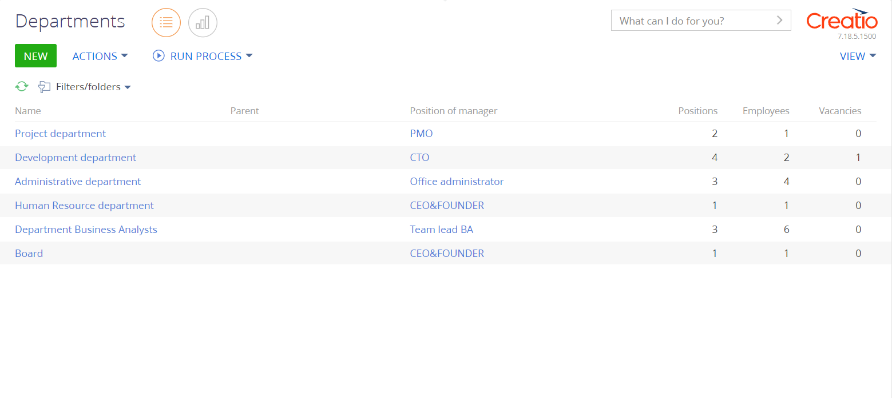
Follow the steps below to add a department to the system:
- Open workplace [HRMS settings]
- Go to section [Departments]
- Click [Add]
- In the card that opens fill out the required field [Title]
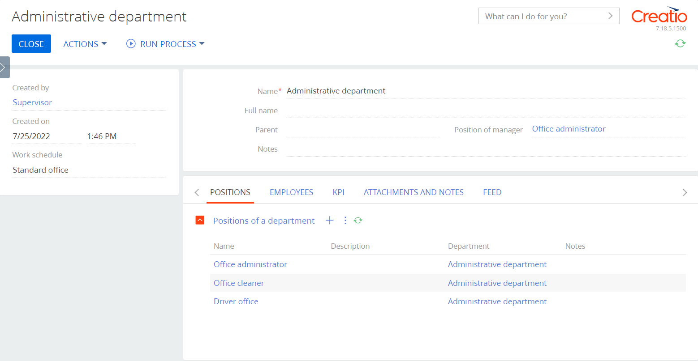
- To add details the section, fill in the optional fields of the card:
- [Full title] text field to enter a user-defined title
- [Parent department] Click , and select the required department from the directory
- [Senior manager position] click , and select the required position from the directory. Functionality available after creating positions in the organization.
- [Notes]
- [Work schedule] - click to open a drop-down list to select a work schedule.
- [Generated by] – employee that is responsible for generating the department card. Pulls up automatically, to choose another employee click .
- [Date of entry] – the current date is automatically inserted. Click to choose another date
- [Time of entry] – the current time is automatically inserted. Click to open a drop-down list to select time.
- Click [Save]

How to generate a position in the organizational structure of the company
Contains records of all positions in a company.
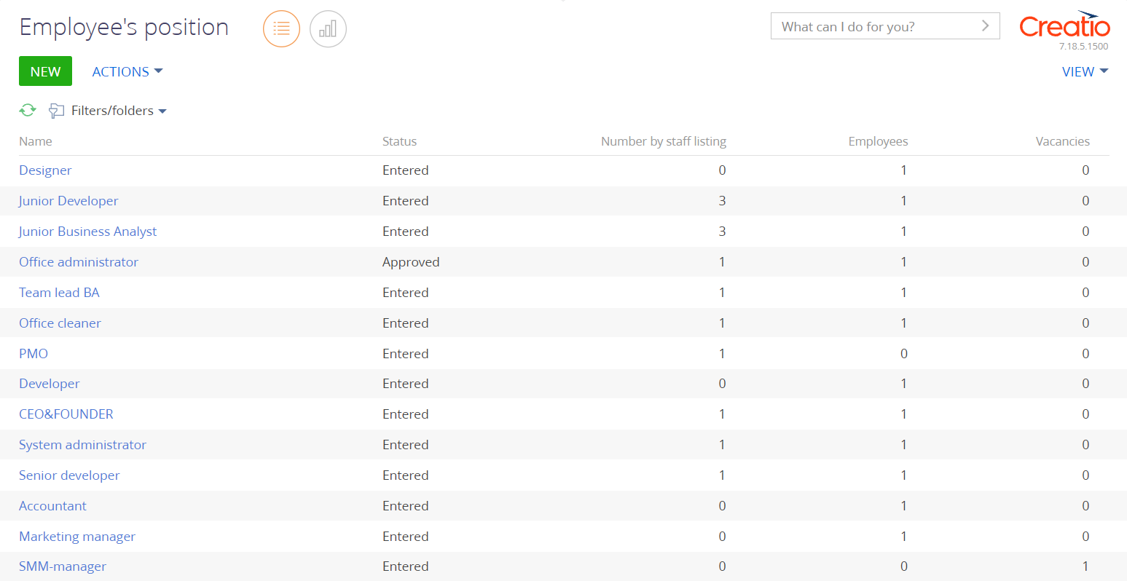
Follow the steps below to add a position to the system:
- Open workplace [HRMS settings]
- Go to section [Employees positions]
- Click [Add]
- Fill out the following mandatory fields of the opened mini-card:
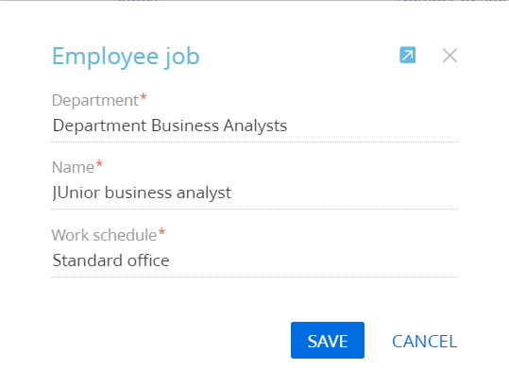
- [Department] - Click and select the required department from the directory
- [Title] – text field for entering a user-defined title
- [Work schedule] - click to open a drop-down list to select a work schedule.
- Click [Save] to generate a new entry
- To continue editing entry of a new position according to the configured case of the department, click on the title of the generated position. A full card opens for detailed position configuration.
- Fill in the required fields on the left side of the card:
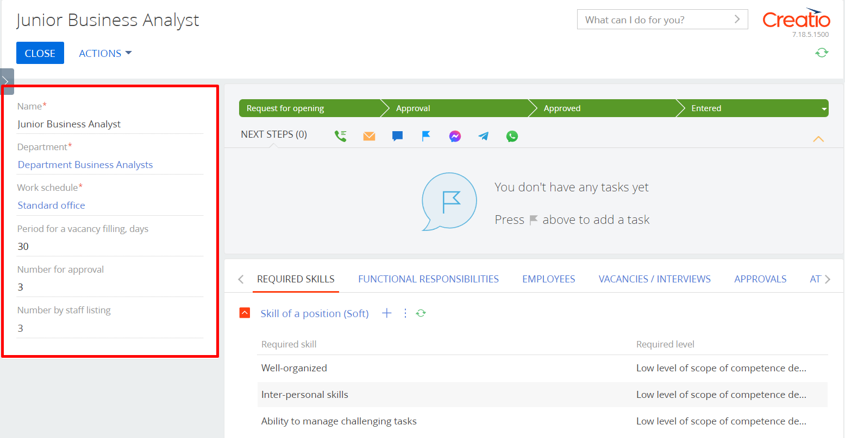
- [Quantity for approval] - number of full-time employees
- [Vacancy filling period, days] – number of days allowed for vacancy filling.
- Click [Save]

How to generate a position through the section [Departments]
Follow the steps below to add a position to a department:
- Open workplace [HRMS settings]
- Go to section [Departments]
- Open entry card and go to tab [Positions]
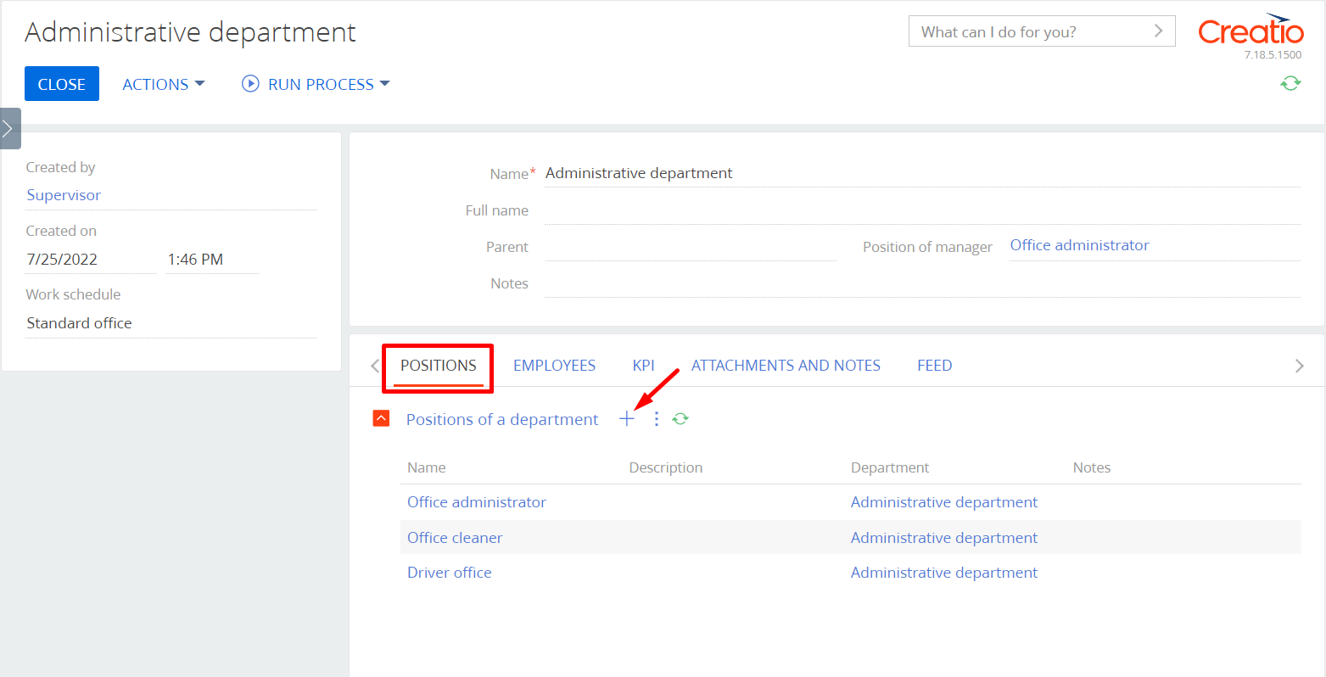
- Click in detail [ Positions of the department]
- Fill out the following fields in the mini-card:
- [Department] - filled out automatically
- [Title] - a text field to enter a user-defined title
- [Work schedule] - click to open a drop-down list to select a work schedule.
- Click [Save] generate a new entry
- To continue editing entry of a new position according to the configured case of the department, click on the title of the generated position. A full card opens for detailed position configuration.
- Fill in the following mandatory fields:
- [Quantity for approval] - number of full-time employees
- [Vacancy filling period, days] – number of days allowed for vacancy filling.
- Click [Save] to save changes.

How to add functional responsibilities to the system
A section that displays a list of all functional responsibilities in a company.
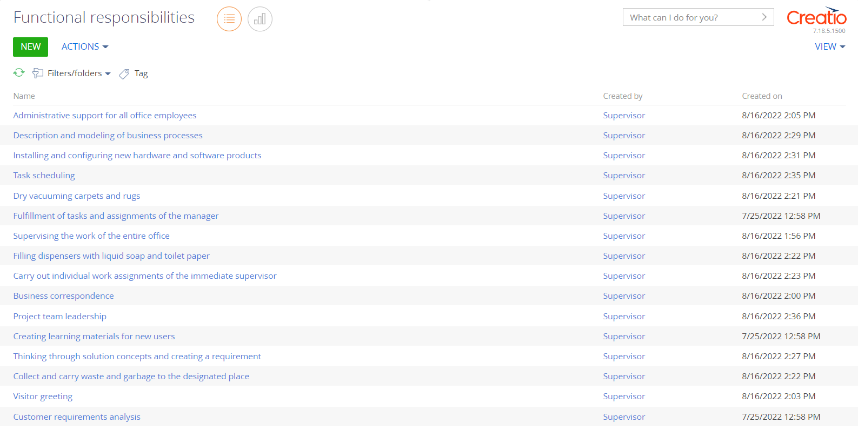
Follow the steps below to add functional responsibilities to the system:
- Open workplace [HRMS settings]
- Go to section [Functional responsibilities]
- Click [Add]
- In the opened card, fill out the field:
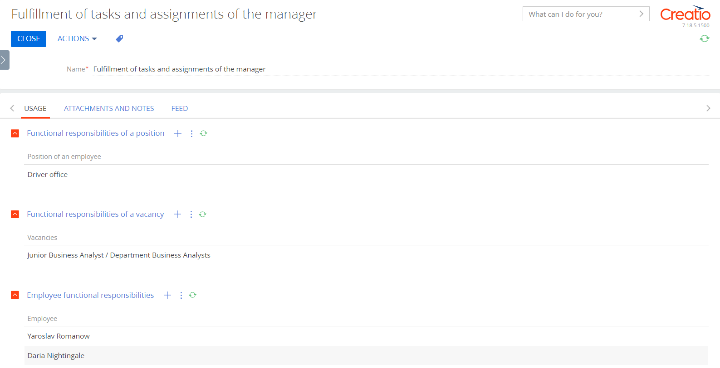
- [Title] - text field to enter user-defined title
- On the [Usage] tab, use in the details to specify where exactly tit should be used:
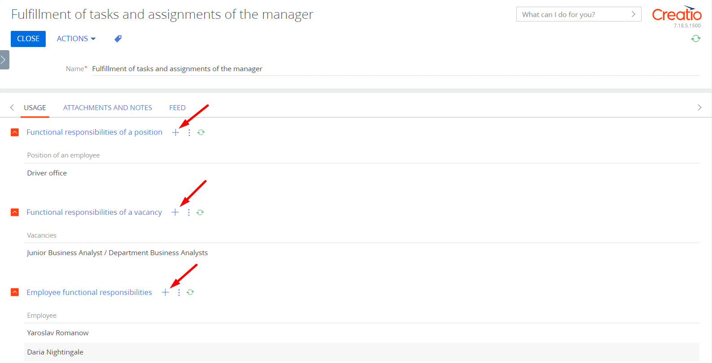
- [Functional responsibilities of a position]
- [Functional responsibilities of a vacancy]
- [Functional responsibilities of an employee]
- Click [Save]

How to add skills and scope of competence to the system
Follow the steps below to add skills and scope of competence to the system:
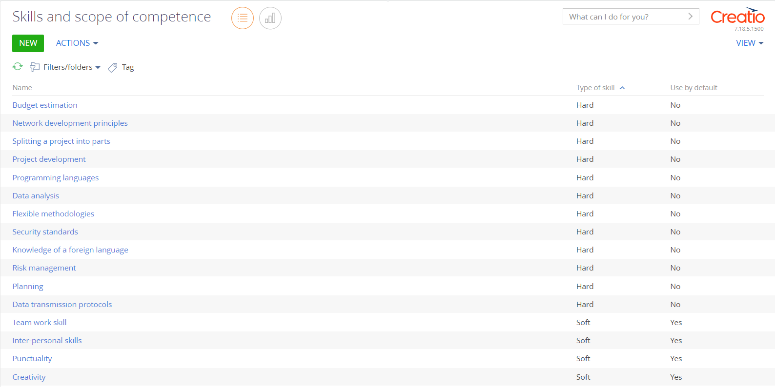
- Open workplace [HRMS settings]
- Go to section [Skills and scope of competence]
- Click [Add]
- In the opened card, fill in the required fields:
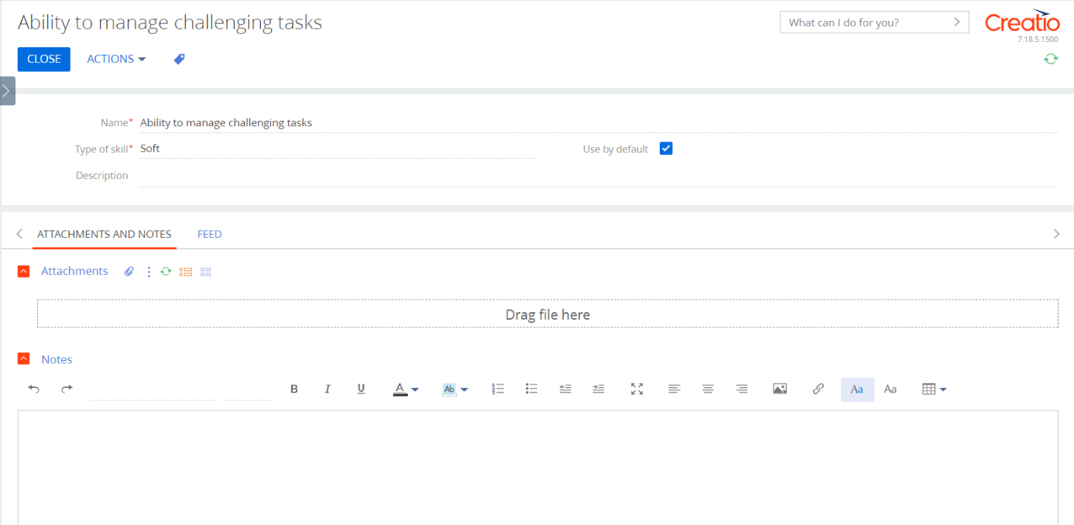
- [Title] - a text field to enter a user-defined title
- [Skill type] Click to open the drop-down list
- If necessary, fill in the following optional fields:
- [Description]
- [Use by default] – tick the checkbox to use this skill by default
- Click [Save]
Important
Skills and scope of competence marked as [Use by default] will be automatically added to new position vacancies to which they are attached.

How to specify functional responsibilities of a position
Follow the steps below to add functional responsibilities to a position:
- Open workplace [HRMS settings]
- Go to section [Employees positions]
- Open position card and go to the tab [Functional responsibilities]
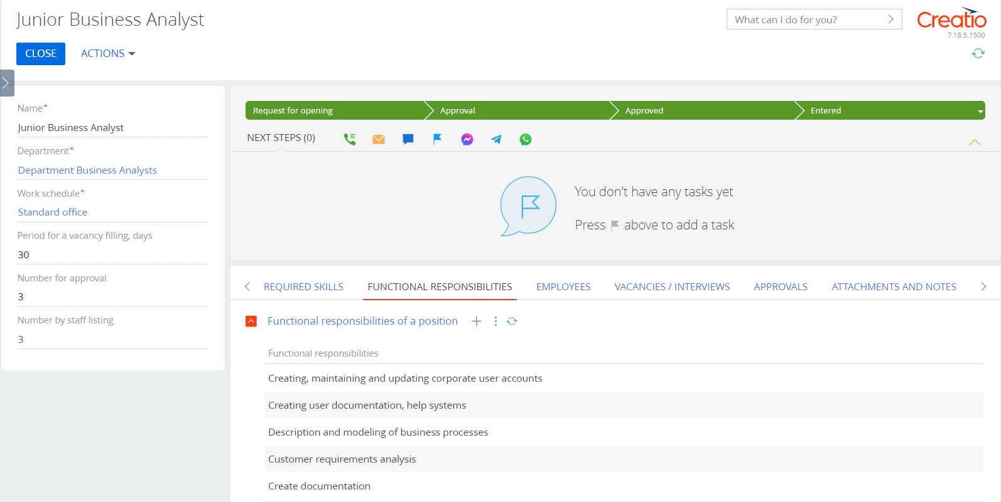
- Click in detail [Functional responsibilities of a position]
- In the multiple selection window, set opposite the items you need
- Click [Select] to save the selected results

How to indicate level of skills and scope of competence required for a position
- Open workplace [HRMS settings]
- Go to section [Employees positions]
- Open position card and go to tab [Required skills]
- In order to add a necessary SOFT skill to the position, click in detail [Position skill (Soft)]
- In the multiple-selection directory, set opposite the items you need
- Click [Select] to save the selected results
To specify the level of the selected skill, click on the entry field. Click in the field [Required level] and select the required option from the directory.
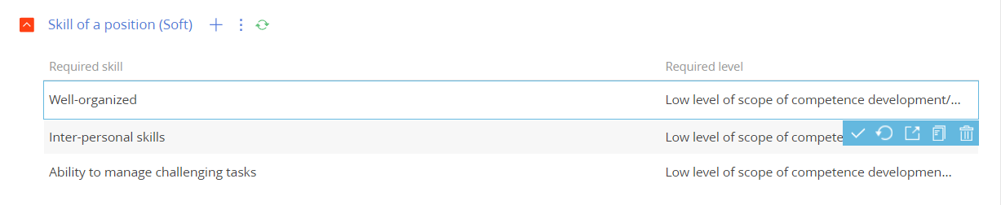
To add required HARD competence to a position, click in detail [Position Skill (Hard)]
- In the multiple-selection directory, set opposite the items you need
- Click [Select] to save the selected results
- To indicate the level of the selected competence, click on the entry field. Click in the field [Required level] and select the required option from the directory.
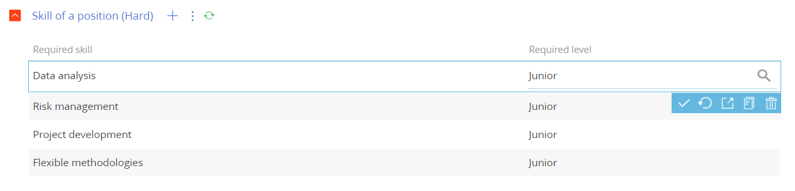

How to generate a contact/employee
Follow the steps below to add a contact to the system:
- Open workplace [HRMS Recruiting]
- Go to section [Contacts]
- Click [Add contact]
- In the mini-card, fill in the following mandatory fields:
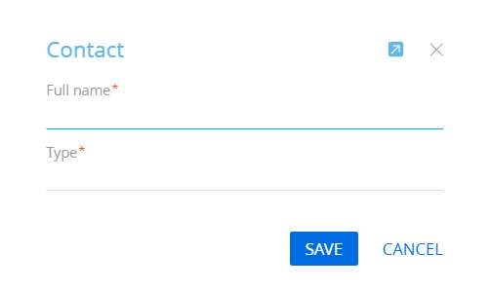
- [Full name]
- [Type] – the status of the contact in respect of the company. Select type "Employee" to generate an employee contact
- Click [Save]
- To continue working with the entry of a new contact, click on the generated entry. A full card opens for filling out the contact card in detail.
Important
An "Employee" contact type must be linked to a position in a company.

How to link an "Employee" contact type to a position
Follow the steps below to link an "Employee" contact type to a position:
- Open the workplace [HRMS personnel]
- Go to section [Employees]
- Click [Add employee]
- In the mini-card, fill out the following mandatory fields:
- [Contact] Click , and select the necessary contact from the directory
- [Contractor] Click , and select the required option
- [Department] Click to open the drop-down list
- [Position] Click to open the drop-down list
- Click [Save]
- In the opened card, fill in the field:
- [Career starting date] the current date is automatically inserted. Click to choose another date
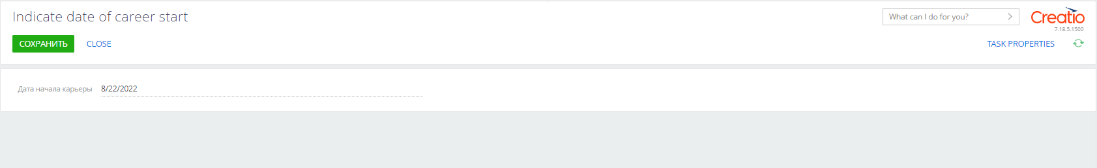

Case work description "Employees Positions/Basic"

Status "Application for opening"
Specify the planned number of employees and the planned number of days for vacancy filling | Editing page | Mandatory fields must be filled in, by default they are:  - Quantity to be agreed  - Vacancy filling period, days  Optionally specify:  - Functional responsibilities of a position  - Skills and scope of competence
Send for approval | Activity | Reminder to send the vacancy for approval to a senior manager

Status "Approval in progress"
Approve the terms of the position | Permitting | Starts the permission approval process for the head of the department
Approve permission | Activity | Activity for the head of a department

Status "Approved"
Copying the planned number of positions to the staff | Subprocess
Process a new vacancy | Activity | Activity for the head of a department

Status "Entered"
Final stage, successful.
Generating a vacancy from a position | Subprocess | A user gets a generated question about the possibility of creating a vacancy from the current position

Status " Cancelled "
Final stage, not successful, no activity or business process.

Management of vacancies and interviews

How togenerate a vacancy
Follow the steps below to generate a vacancy:
- Open workplace [HRMS recruiting]
- Go to section [Vacancies]
- Click [Add]
- The following mandatory fields appeared in the mini - card:
- [Department] clickto open the drop-down list
- [Position] click to open the drop-down list
- Click [Save]
- To continue editing entry of a new vacancy according to the configured case of the department, click on the title of the generated vacancy. A full card opens for detailed position configuration.
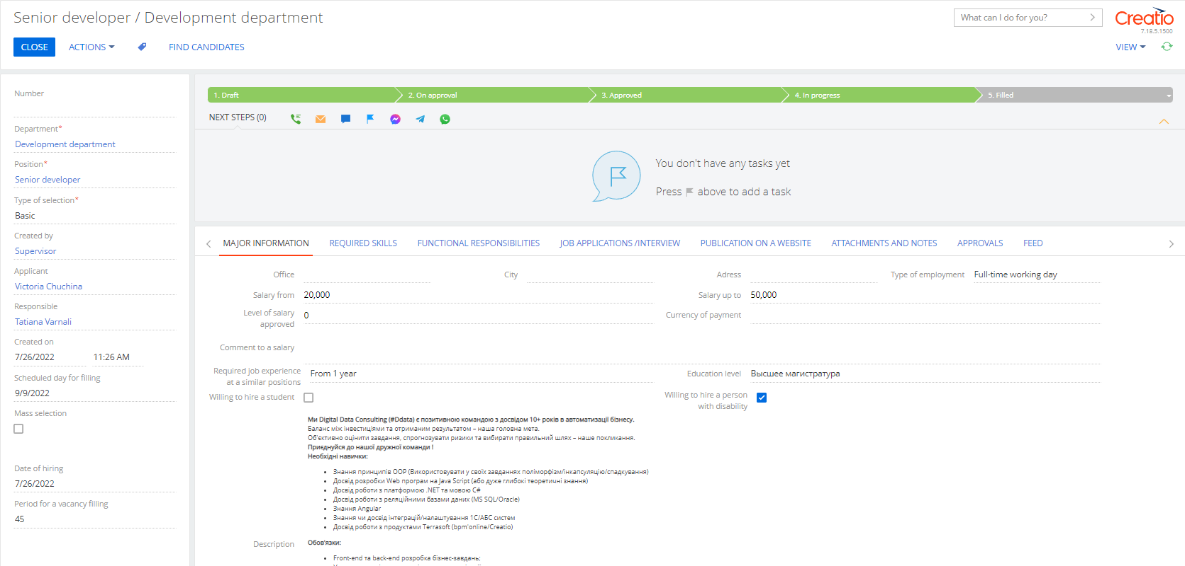
- In the full card that opens, fill out the required fields:
- [Selection type]
- [Responsible employee]
- Fill out the remaining fields in the card to provide detailed information regarding a vacancy and on the tabs [Basic information], [Necessary skills], [Functional responsibilities].
- Click [Save]. The vacancy application is sent to the applicant for approval (or adjusted according to the company's business cases)
Checkbox [Mass recruitment] – allows to fill out the required number of vacancies without creating a new vacancy application.
Tabs [Necessary skills], [Functional responsibilities] - will be filled out automatically from the position, provided that they are filled out in the card.

How to specify vacancy functional responsibilities
Functional responsibilities are added to a vacancy automatically from a position, provided that they are filled out in the position card.
Learn more about adding functional responsibilities here

How to specify required skills and scope of competence for a vacancy
Skills and scope of competence are automatically added to a vacancy from a position, provided that they are filled out in the position card.
Learn more about adding skills and competencies here

Case work description "Vacancies/Basic"

Status "Draft"
Estimation of the planned vacancy filling date and the required number of employees | Subprocess | A business process that sets the desired vacancy filling, according to the established term of a position
Fill out the application for opening a vacancy with all the necessary data | Activity | Reminder to send a vacancy for approval by a manager
Specify the responsible employee | Editing page

Status "On approval"
Check vacancy application | Activity
Approve the vacancy | Permitting

Status " Approved "
Launch a vacancy | Activity

Status “In progress”
Date of employment | Subprocess | A business process that sets the start date of a vacancy launch
Check the vacancy for relevance | Activity

Status " Closed "
Final stage, successful.
Estimation of the actual vacancy filling date | Subprocess | A business process that enters the actual vacancy filling date

Status " Cancelled "
Final stage, not successful, no activity or business process

How to generate a job interview
There are two ways to add a job interview:
Method 1
- Open workplace [HRMS Recruiting]
- Go to section [Vacancies]
- Select the required entry and go to tab [Job applications/Interview]
- Click in detail [Interviews]
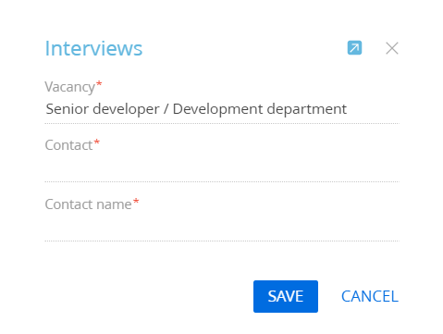
- Fill in the required fields:
- [Vacancy] – filled out automatically
- [Contact] click , and select the required contact from the directory of existing contacts
- [Contact name] – fill out if the contact is not in the system to generate a new contact
- Click [Save] to generate a new interview entry.
Method 2
- Open workplace [HRMS recruiting]
- Go to section [Interview]
- Click [Add]
- Fill in the required fields:
- [Vacancy] Click to open the drop-down list
- [Contact] click , and select the required section from the directory
- [Contact name] – fill out if the contact is not in the system to generate a new contact
- Click [Save] to generate a new interview entry

How to add an interview comment
Follow the steps below to add a comment to an interview:
- Open workplace [HRMS Recruiting]
- Go to section [Interview]
- Select the required entry and go to tab [Skill assessment]
- Click in detail [Interview comments]
- In the opened card, fill out the field [Comment]
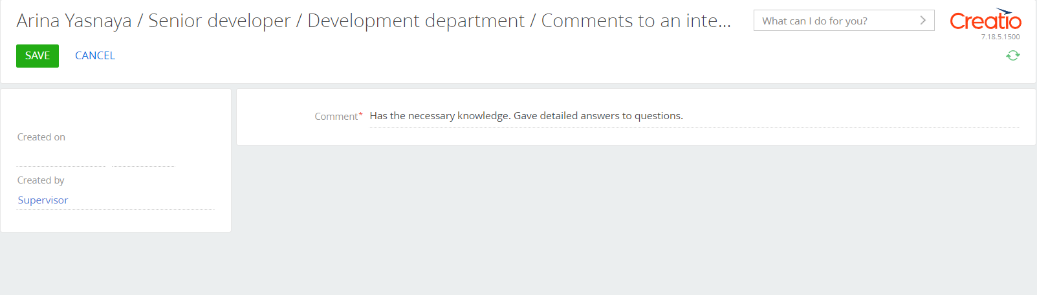
- Click [Save]

How to indicate the candidate's current level of skills and scope of competence
Follow the steps below to indicate a candidate's current level of skills and scope of competence:
- Open workplace [HRMS Recruiting]
- Go to section [Interviews]
- Select the required entry and go to tab [Skills assessment].
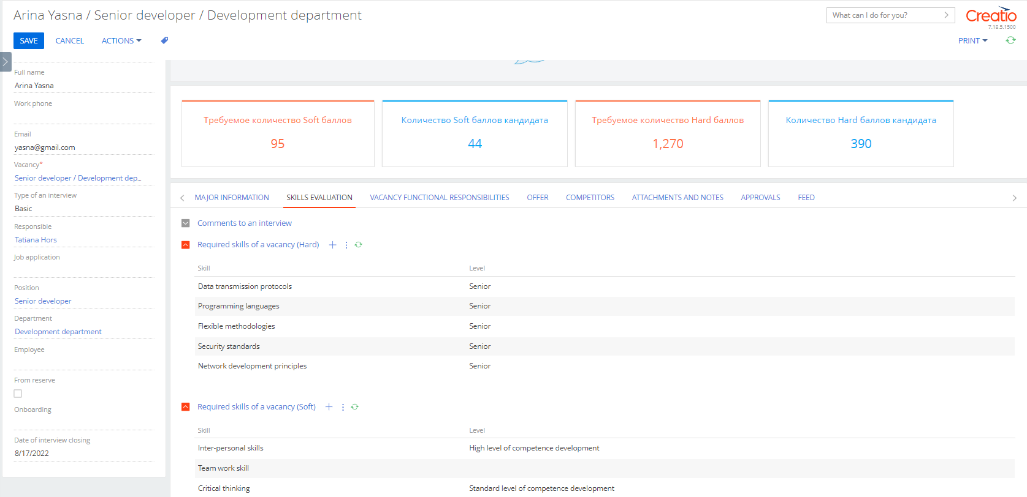
- To indicate the current skill level of a candidate, click on the required skill in details [Contact skill (Soft)] and fill out the field:
- [Current level] to open the skill level directory, click , specify the required level and click [Select] and then Click
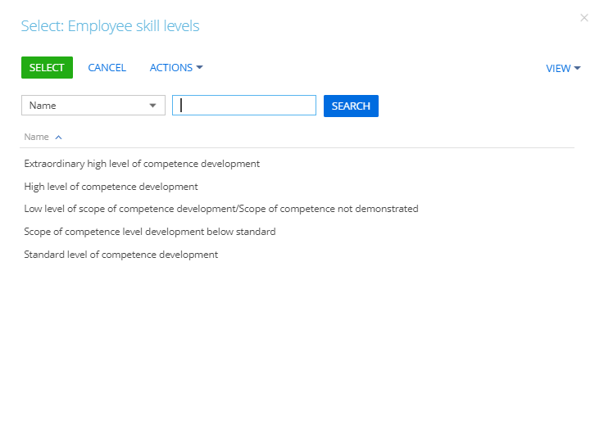
- To indicate the current skill level of a candidate, click on the required skill in details [Contact skill (Hard)] and fill out the field:
- [Current level] to open skill level guide click , specify the required level and click [Select] and then click
- Click [Save] to save the changes introduced to the card.

Case work description "Interview/Basic"

Status "Communications"
Get in touch with the contact | Activity | Reminder to a responsible contact to process an interview

Interview scheduled " status
Interview of a candidate for a vacancy | Activity | Generate an activity and specify the time of an interview and participants

“Prior approval” status
Approve a candidate | Permitting

Status “Second interview”
Final stage, successful.
Interview of a candidate for a vacancy | Activity | Generate an activity to specify its time and participants

Status "Pending company's decision"

To specify according to company's decision | Activity | Reminder to a responsible contact to process an interview

Status “Approved”
Get in touch with a contact | Activity | Reminder to a responsible contact to process an interview

Status “pending candidate 's decision”
Clarify candidate's decision | Activity | Reminder to a responsible contact to process an interview

Status “Pending work commencement”

Planned date of commencement to work | Subprocess | A business process that requires specification of a planned date of candidate’s commencement to work.
Check commencement of a candidate to work | Activity | Reminder to a responsible contact to process an interview
Generating Onboarding | Subprocess | A business process that, if necessary, generates onboarding of an employee

Status “Employed”

Generation of an employee | Subprocess | A business process that generates a new employee based on the results of an interview
Check for vacancy filling upon hiring | Subprocess | A business process that checks terms of a vacancy and, if necessary, closes it and related interviews

Status “Transfer to reserve”

Transfer of a candidate to reserve + copying of skills and their assessment | Subprocess | A business process that marks a contact "To reserve"

Status “Declined by a company”
Company declines a candidate | Subprocess | A business process that specifies the reasons for declining of a candidate
Notify a candidate about decline | Activity

Status “Candidate rejected”

Candidate rejected a vacancy | Subprocess | A business process that specifies the reason for a candidate's rejection

Onboarding
After “Offer accepted" status, the system offers to generate Onboarding for a new employee. It includes the following activities:
- Preliminary onboarding:
• Prepare a workplace
• Generate an email account
• Check access to all corporate resources/documents
• Prepare Welcome book / Welcome package / Welcome box
- Social Psychological adaptation:
• Welcome training (company strategy/working conditions/schedule, etc.)
• Meeting the team
• Office tour
• Onboarding plan
• 1:1 meeting (HR - employee)
- Professional Onboarding:
• Introduction to position’s responsibilities
• Generate a work plan
• Selection and assigning a supervisor
• KPI/OKR
• Evaluation of results

How to add adaptation status
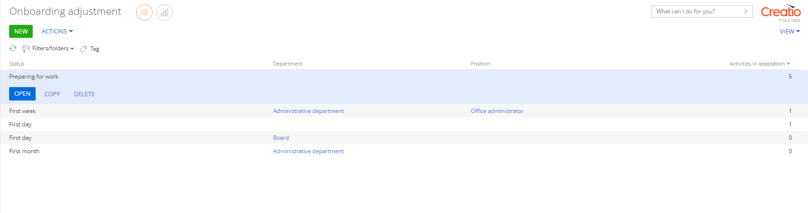
Follow the steps below to configure the adaptation status and its activity:
- Open workplace [HRMS settings]
- Go to section [Onboarding settings]
- Click [Add]
- In the mini-card, fill in the mandatory field:
- [Status] * click to open the drop-down list.
- If necessary, fill in the following optional fields:
- [Department] ** click to open the drop-down list
- [Position] *** after selecting a unit. Click to open the drop-down list
- Click [Save]
* [Status] – general activity for all employees of a company.
** [Status - Department] – general activity for all employees of a department.
*** [Status – Unit – Position] – general activity for all employees of a position.

Adding activity by stage of Onboarding
Onboarding activity settings are generated for a specific Onboarding status. You can specify these activity sets according to a department and position.
Follow the steps below to add an activity into Onboarding stages:
- Open the workplace [HRMS settings]
- Go to section [Onboarding settings]
- Open the required entry and go to the tab [Activities]
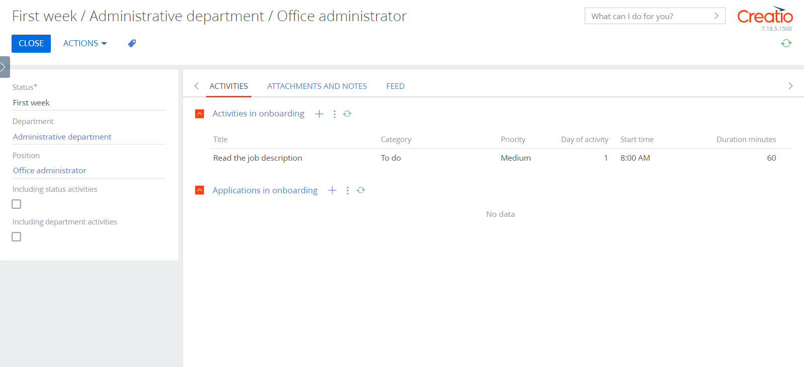
- Click in detail [Activities in onboarding]
- In the opened card, fill in the following mandatory fields:
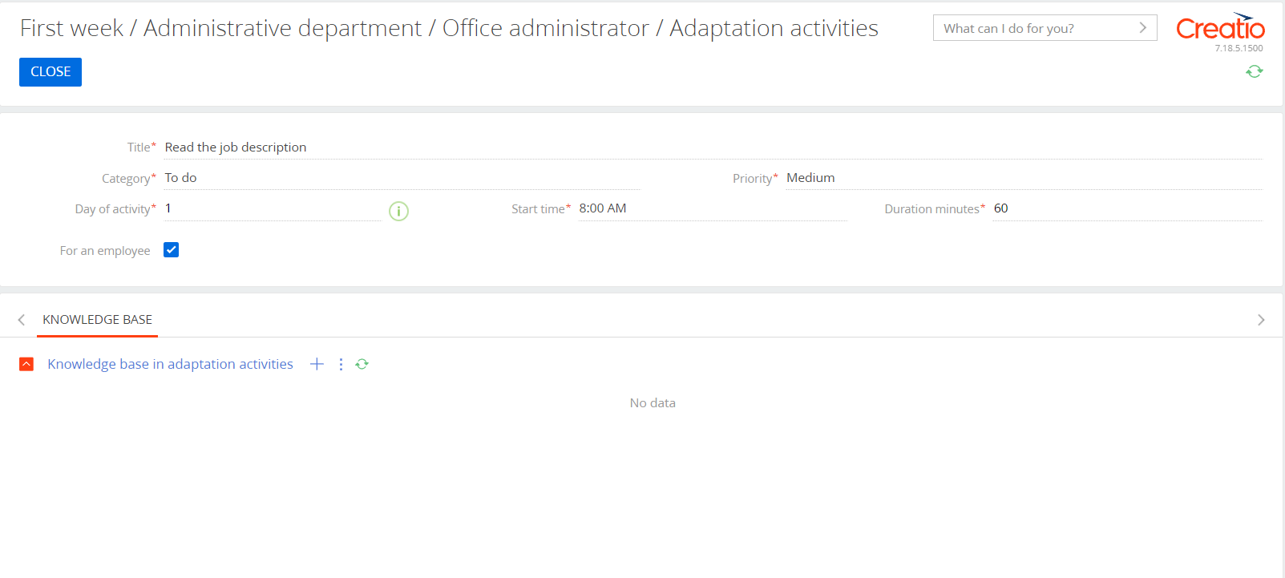
- [Title] - text field to enter a user-defined title
- [Category] click , and select the necessary activity category from the directory
- [Day of activity] for which, after the start of the stage, the activity will be performed
- [Priority] click, and select the required activity priority from the directory
- [Starting Time] indicate at what time the activity will be performed on a selected day
- [Duration in minutes] planned period of carrying out
- [Per employee] (checkbox) – to assign an activity to a new employee (For example: review documents)
- [To manager of employee] (checkbox) – to assign a new employee to a manager (For example: introduce an employee to functional responsibilities)
- [To a position] – click , and select a position from the directory. (For example: Prepare a laptop - System administrator)
- [To department] – click , and select a department from the directory
- If necessary, fill in [Knowledge base article for adaptation] detail on the [ Knowledge base] tab, click and select the required entries from the multiple-selection list. Knowledge base articles are attached for study and faster onboarding.
- Click [Save] to save the selected results
- If necessary, specify the sets of these activities for the department and position, using the checkboxes:
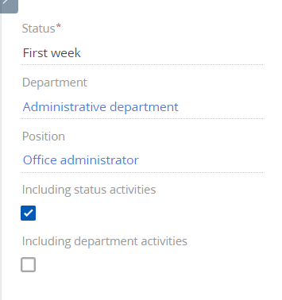
- [Including status activities] - includes all activities according to status
- [Including activities of a department] - includes all activities of a department to which the position is assigned.
- Click [Save] to save the results.

How to add Onboarding to an employee
After accepting an offer and setting [Career start dates] and [Probation period] to an employee, the system will automatically add onboarding that is configured for such position and department.

Offboarding

How to add offboarding status
Follow the steps below to add offboarding status:
- Open workplace [HRMS settings]
- Go to section [Offboarding adjustment]
- Click [Add]
- In the mini-card, fill out the mandatory field:
- [Status] Click to open the drop-down list
- If necessary, fill out the following optional fields:
- [Department] Click to open the drop-down list
- [Position] after selecting a department. Click to open the drop-down list
- Click [Save]
* [Status] – general activity for all employees of a company.
** [Status - department] – general activity for all employees of a department.
*** [Status – department – position] – general activity for all employees of a position.

Adding activity to offboarding stage
Offboarding activity settings are generated for a specific Offboarding status. You can specify these activity sets according to a department and position.
Follow the steps below to add an activity to offboarding stage:
- Open the workplace [HRMS settings]
- Go to section [Offboarding adjustment]
- Open the required entry and go to the tab [Activities]
- Click in detail [Activities in offboarding]
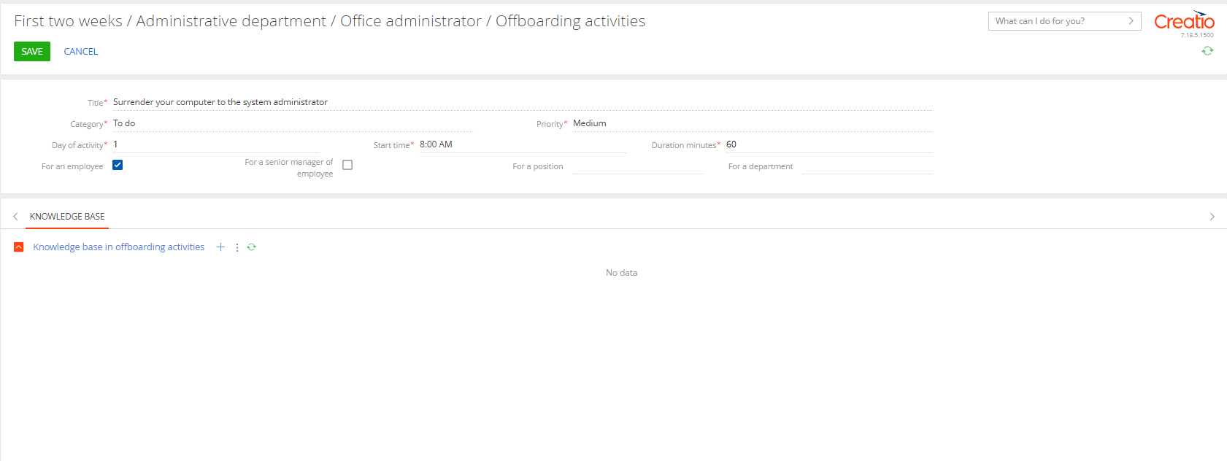
- In the opened card, fill in the required fields:
- [Title] - text field to enter a user-defined title
- [Category] click , and select the required activity category from the directory
- [Day of activity] on which, after the start of the stage, the activity will be performed
- [Priority] click , and select the desired activities priority from the directory
- [Start Time] indicate at what time an activity will be performed on a selected day
- [Duration minutes] planned period of coring out
- [Per employee] (checkbox) – to assign activity to an employee who is being dismissed
- [To a manager of an employee] (checkbox) – to appoint a manager of an employee who is being dismissed (For example: introduce an employee to functional responsibilities)
- [To position] – Click , and select a position from the directory. (For example: Prepare a laptop - System administrator)
- [To department] – Click , and select department from the directory
- If necessary, fill out the [Knowledge base article for offboarding] detail on the [Knowledge base] tab, click and select the required articles from the multiple list. Articles of the knowledge base for the execution (passing) of the offboarding procedure are attached.
- Click [Save] to save the selected results
- If necessary, specify the sets of these activities for a department and position, using the checkboxes:
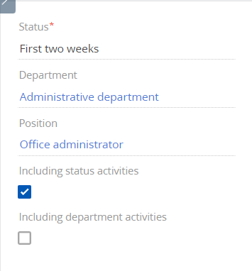
- [Including status activities] - includes all activities by status
- [Including activities of a department] - includes all activities of a department to which the position is assigned.
- Click [Save] to save the results.

How to add offboarding to an employee
After the decision on offboarding, an employee is transferred to status [In the process of offboarding]. The system will automatically add offboarding activity that is configured for such position and department.

KPI management

How to add KPI measurements to the system
Follow the steps below to add KPI to the system:
- Open workplace [HRMS KPI]
- Go to section [KPI measurements]
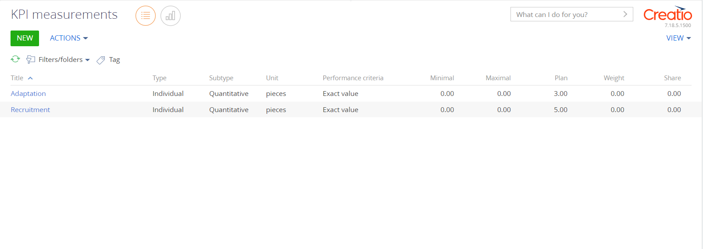
- Click [Add]
- In the opened card, fill in the following mandatory fields:
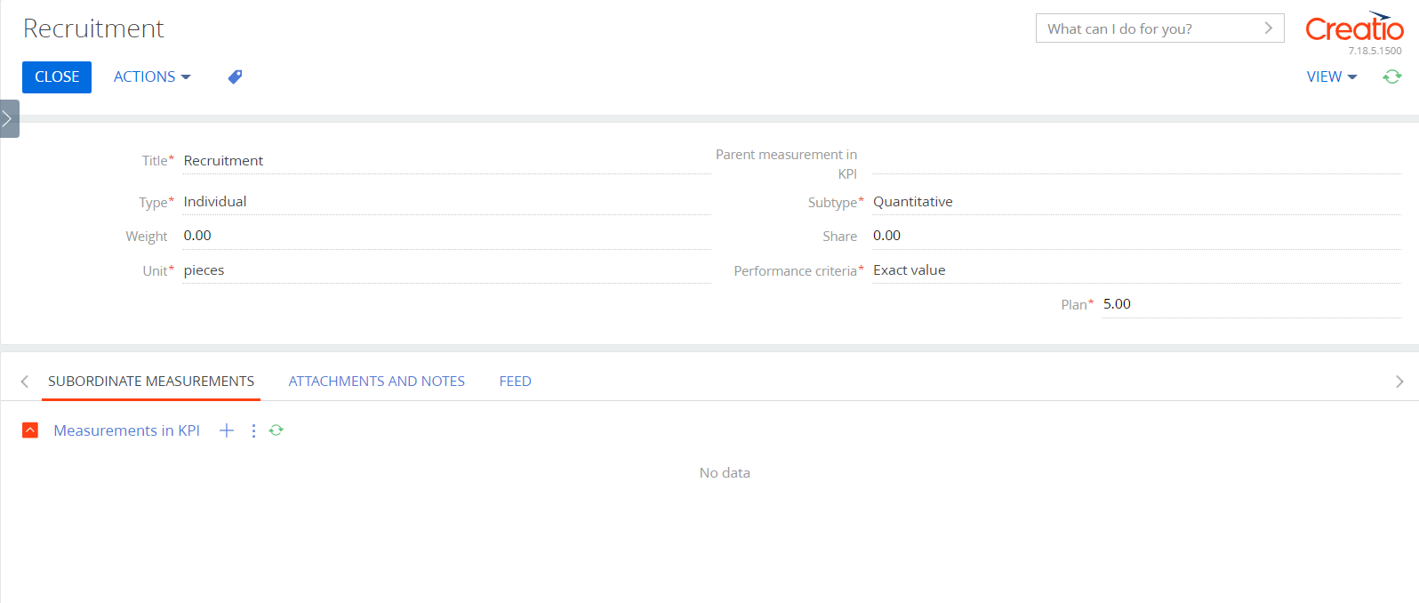
- [Title] - text field to enter a user-defined title
- [Type] - click to open the drop-down list. Choose one of the options: individual; group
- [Subtype] - if individual. Click to open the drop-down list
- [Units of measurement] Click to open the drop-down list
- [Performance criterion] Click to open the drop-down list. Choose one of the options: More is better; Less is better; Exact value
- [Minimum] – if the performance criterion is "More is better"
- [Maximum] – if the performance criteria are "Less is better"
- [Plan] – if the performance criterion is "Exact value"
- If necessary, fill in the following fields:
- [Weight]
- [Parent indicator in KPI] click , and select the desired KPI from the guide
- [Particle]
- Click [Save] to save the selected results

How to generate a KPI setting template
Follow the steps below KPI production template to the system:
- Open the workplace [HRMS KPI]
- Go to section [ KPI templates]
- Click [Add]
- In the opened card, fill in the following mandatory fields:
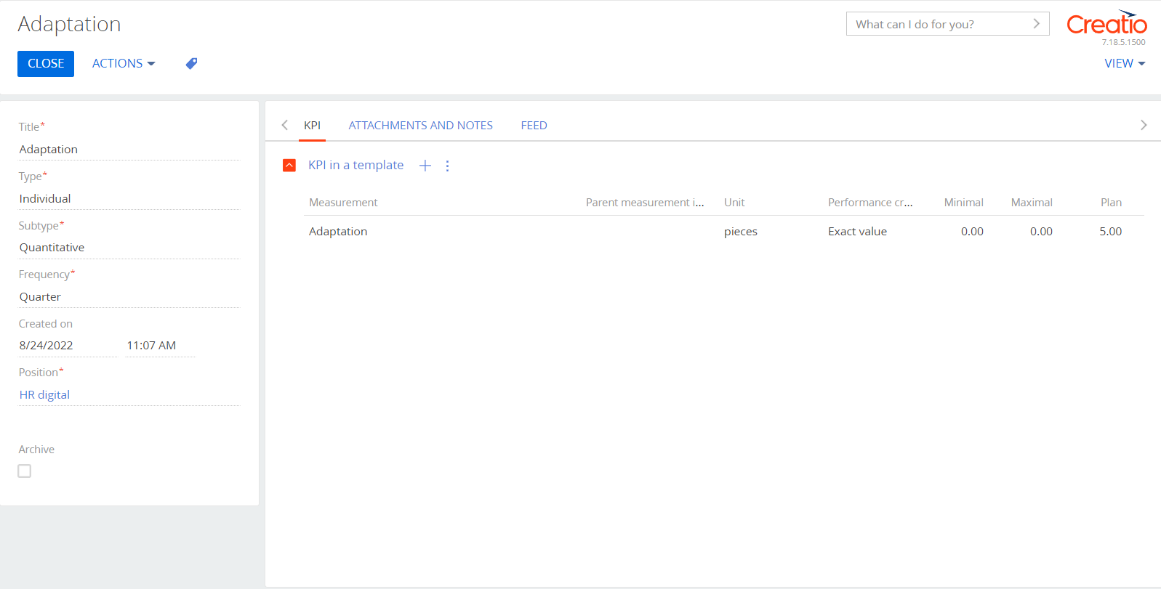
- [Type] - click to open the drop-down list. Choose one of the options: individual; group
- [Subtype] - if individual. Click to open the drop-down list
- [Periodicity] Click to open the drop-down list
- [Position] - if individual. Click and select the required position from the directory
- [Subsection] - if group. Click , and select the required section from the directory
- Click [Save] to save the selected results

How to add a measurement to a template
Follow the steps below to add a KPI to the template:
- Open workplace [HRMS KPI]
- Go to section [KPI templates]
- Select the required entry and go to the tab [KPI]
- To add a KPI to a template, click in detail [KPI in template]
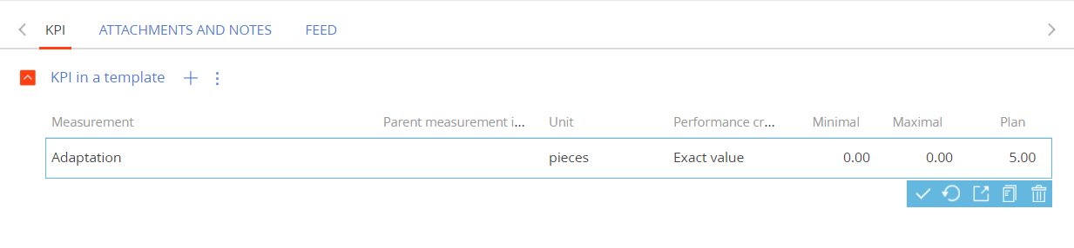
- , fill in the following mandatory fields:
- [Indicator] Click to open the drop-down list and select required indicator
- [Parental]
- [Unit of measurement] Click to open the drop-down list
- [Performance criterion] Click to open the drop-down list. Choose one of the options: More is better; Less is better; Exact value
- [Minimum] – if the performance criterion is "More is better"
- [Maximum] – if the performance criteria are "Less is better"
- [Plan] – if the performance criterion is "Exact value"
- Click , to save selection. Other fields will be filled in automatically.

How to generate a KPI for a department or employee
Follow the steps below to generate KPI per department or employee:
- Open workplace [HRMS KPI]
- Go to section [KPI]
- Click [Add]
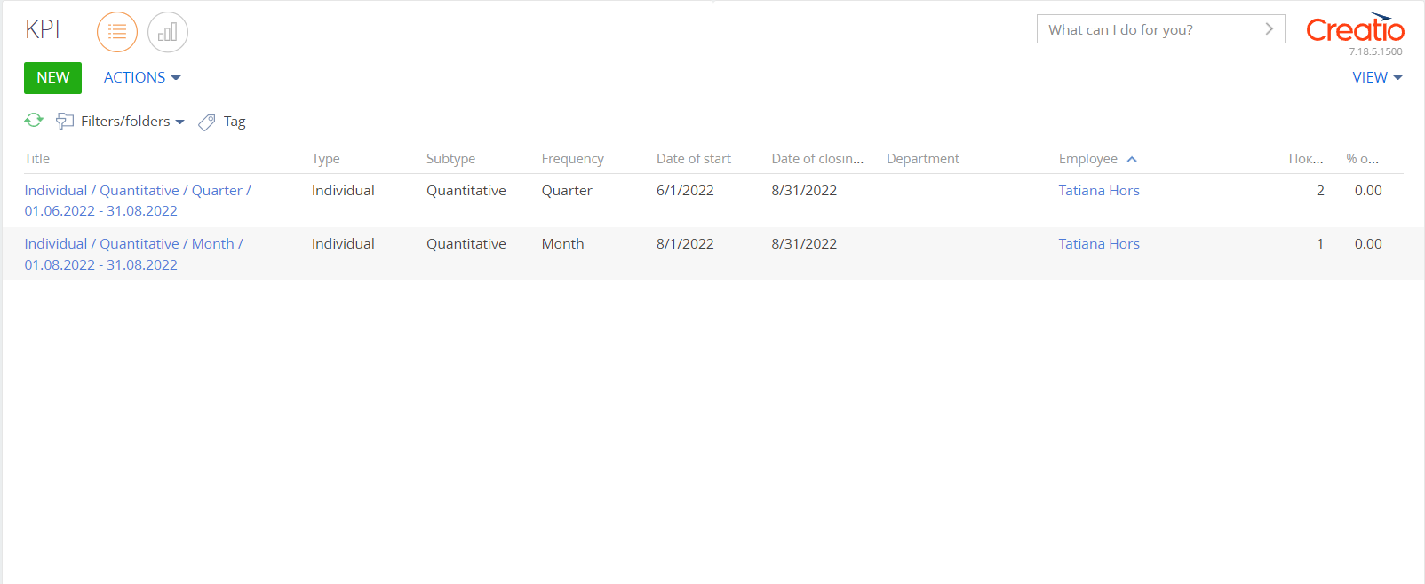
- Fill in the required fields:
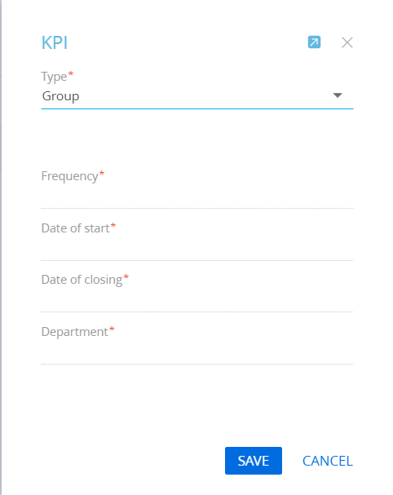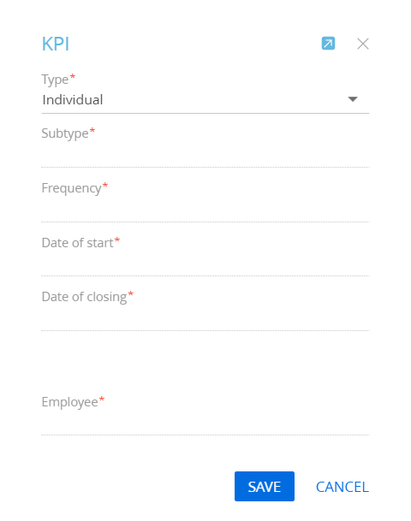
- [Type] Click to open the drop-down list. Choose one of the options: individual; group
- [Subtype], if individual. Click to open the drop-down list
- [Frequency], Click to open the drop-down list
- [Starting Date], click to select a date
- [Ending Date], click to select a date
- [Department], if group. Click to open the drop-down list
- [Employee], if individual. Click to open the drop-down list
- Click [Save] to save the selected results

Case work description "KPI/ Basic "

Status “Approval”
Generation of indicators according to the template | Subprocess | The business process that generates the indicators in this KPI from the corresponding template.
Get acquainted with the new indicators | Activity | Activity per employee

Knowledge base
The company's knowledge base for employees’ development. A register of all the necessary data that may be needed to perform work tasks in one place.

Follow the steps below to add a new article to the knowledge base:
- Open workplace [HRMS settings]
- Go to section [Knowledge base]
- Click [Add article]
- In the window that opens, fill in the required fields:
- [Title] - text field to enter user-defined title
- [Type] Click to open the drop-down list
- On the tab [ Basic information], fill in the editing window with the necessary information. Or add the necessary files on the tab [Files]
