Setting Smarttender connector for Creatio

Setting
Before you begin, you need to set up connection to SmartTender marketplace API. Do the following:
- In the [Lookups] section select [MasterCRM Tender] group and open the lookup [Tender marketplaces connection settings]
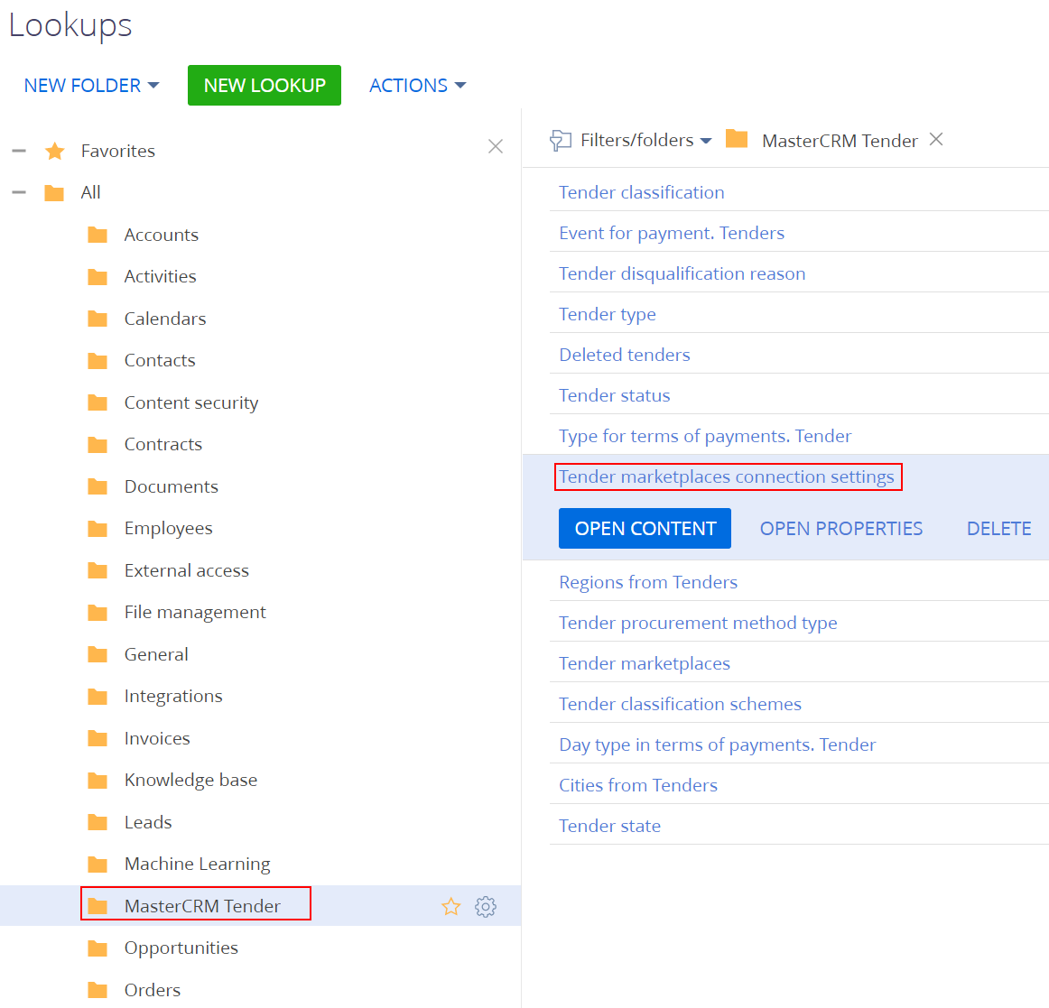
- Lookup contains 2 records for connecting to the public and to the commercial tender marketplaces od SmartTender. You need to fill corresponding parameters (acquired from SmartTender.biz). Settings for the commercial and for the public tenders are specified separately.
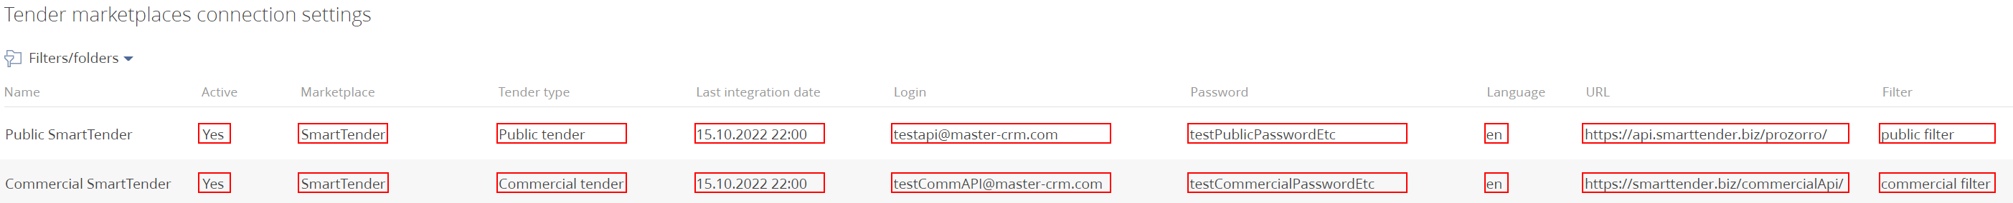
Active – this checkbox activates the connection. It must be activated at the very last stage of the setup.
Marketplace – select from the lookup the marketplace (currently only SmartTender.biz) from which you plan to receive tenders.
Tender type – specify the type of tenders from the lookup (commercial or public).
Last integration date – Date and time when tenders were last received from the marketplace. You can set the date and time of the tender’s last modification on the marketplace, and the connector will try to receive from the marketplace the tenders modified after the specified datetime.
For public tenders from the SmartTender marketplace, there is a limitation of the marketplace –if you’ll ask for a period earlier than 2 days (48 hours) before the current time, the SmartTender public marketplace will give an error.
User name – user login on the marketplace.
Password – the password of the specified user.
Language - the language in which the system will try to receive data from the marketplace. This setting affects directory data and tender data.
url – http(s) endpoint at which the marketplace accepts the API-requests.
Filter is a pre-configured filter group of the Tenders section, in which you can configure the filters of tenders when they are received (and saved in your Creatio site) from the marketplace (if such filters cannot be configured on the marketplace).
- Then run the [Receive lookups SmartTender] business process, it will fill all the necessary reference values that are used.
You can start the process using the global button to start business processes.
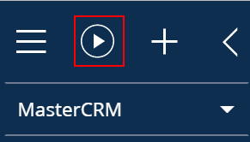
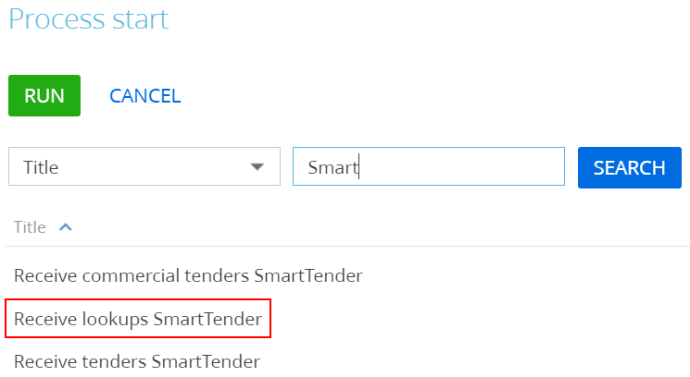
- Wait for the process to complete (it can take up to 30 minutes).
- Return to the Lookup [Tender marketplaces connection settings] and activate the necessary connection.
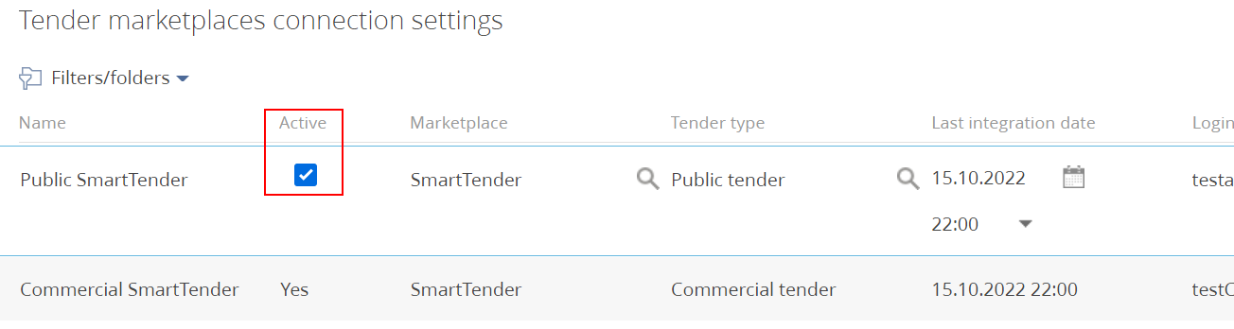
- After that, your Creatio site will poll the marketplace every 5 minutes to receive tenders that have changed since the last integration (settings in p.2).

Filter settings on receiving tenders
Due to various reasons, marketplaces provide limited capabilities to set filters through API.
It is possible to configure additional filters in Creatio. If the tenders does not meet filter conditions such tender will not be saved in your Creatio site.
The connector has preset groups for filtering public and commercial tenders. In addition, it is possible to create your own groups and specify them in the lookup [Tender marketplaces connection settings].
For setting filter in the group
- Show groups in the [Tender] section
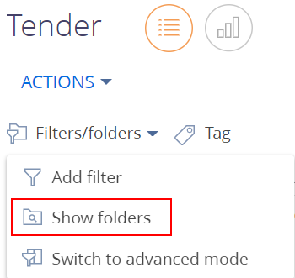
Select “Set up filter” option near the needed group
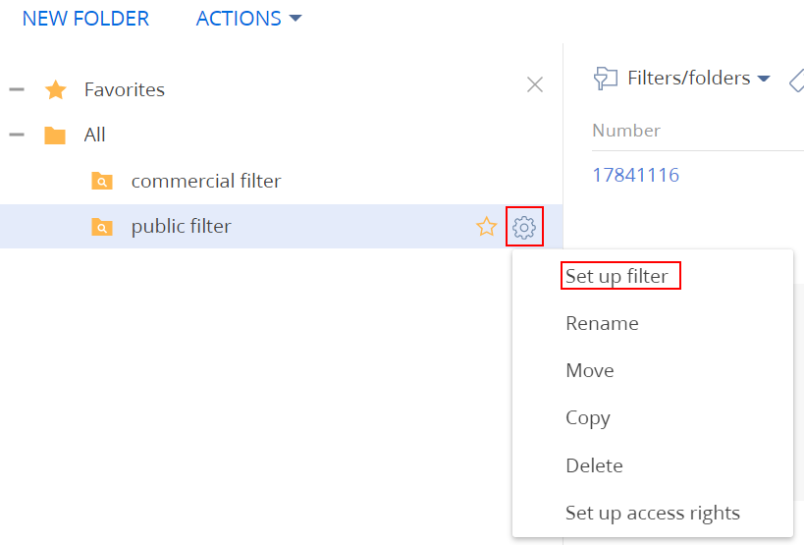
A standard filter settings window for the group will open.
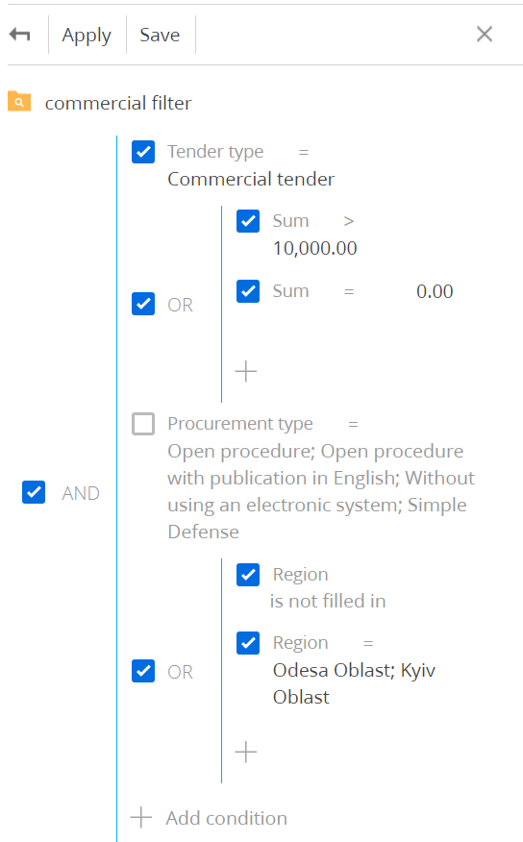
You can adjust the filter to your needs, taking into account the fact that the filter works only on the fields of the main record. Fields from details and related records will not be taken into account when filtering.
After changing the filter, click the “Save” button.
Having selected this group, you can see the result of the selection based on already available entries in the [Tenders] section
- After completing the configuration of the new group, you need to specify the configured group in the “Filter” field of the corresponding entry in the lookup [Tender marketplaces connection settings].

Removal of tenders
If you are not interested in any tender received by the system, you can delete it by clicking the appropriate button. 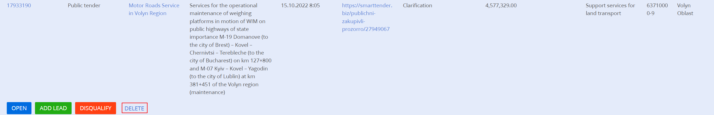 The number of this deleted tender will be saved in the lookup [Deleted tenders] and will not be loaded into your Creatio site again in case of any changes on the marketplace.

