ChatGPT connector for Creatio set-up guide.
1. Sign in your OpenAI account or create new one https://platform.openai.com/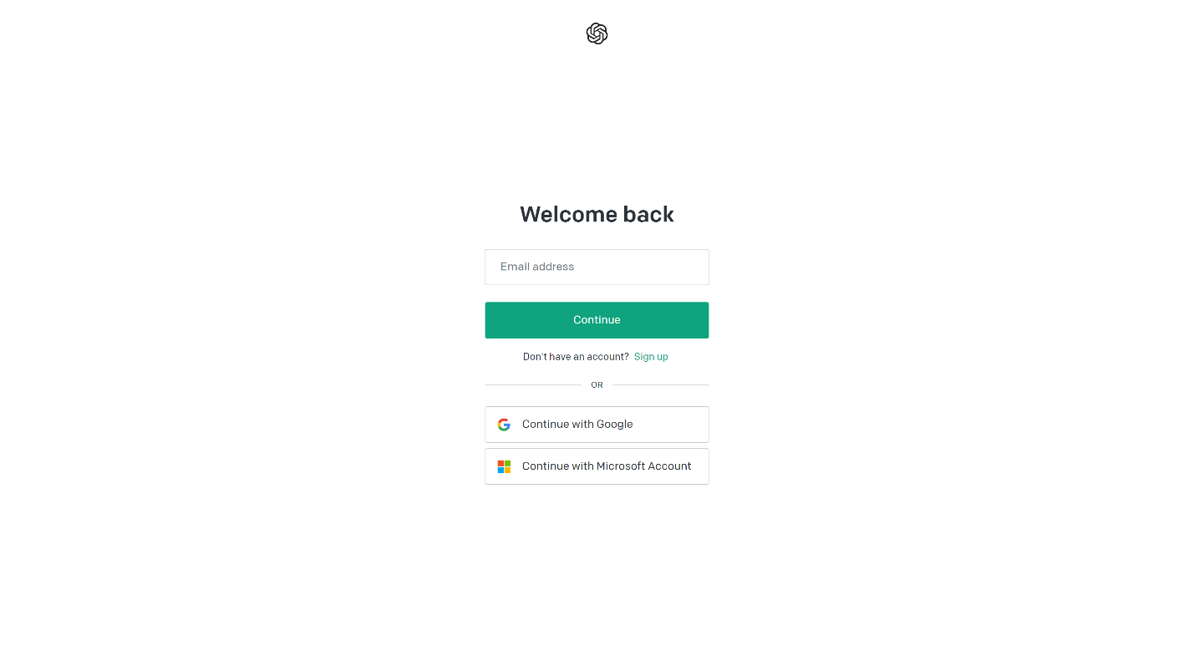

2. In OpenAI platform main page, open the API Keys page (https://platform.openai.com/)
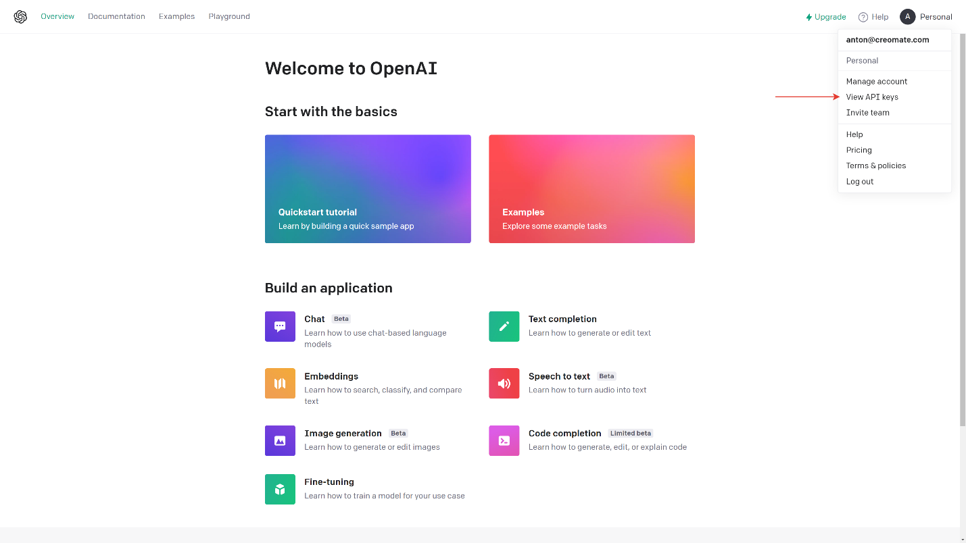

3. Create new key and save it to safe place.
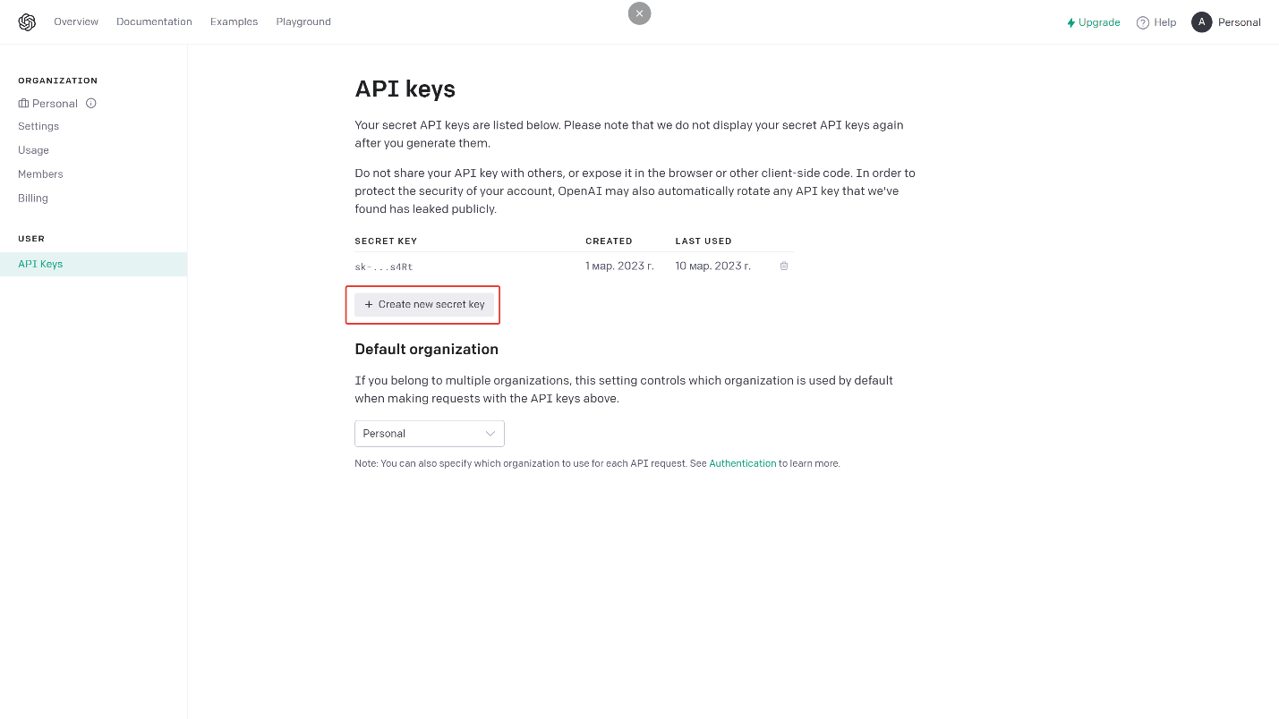
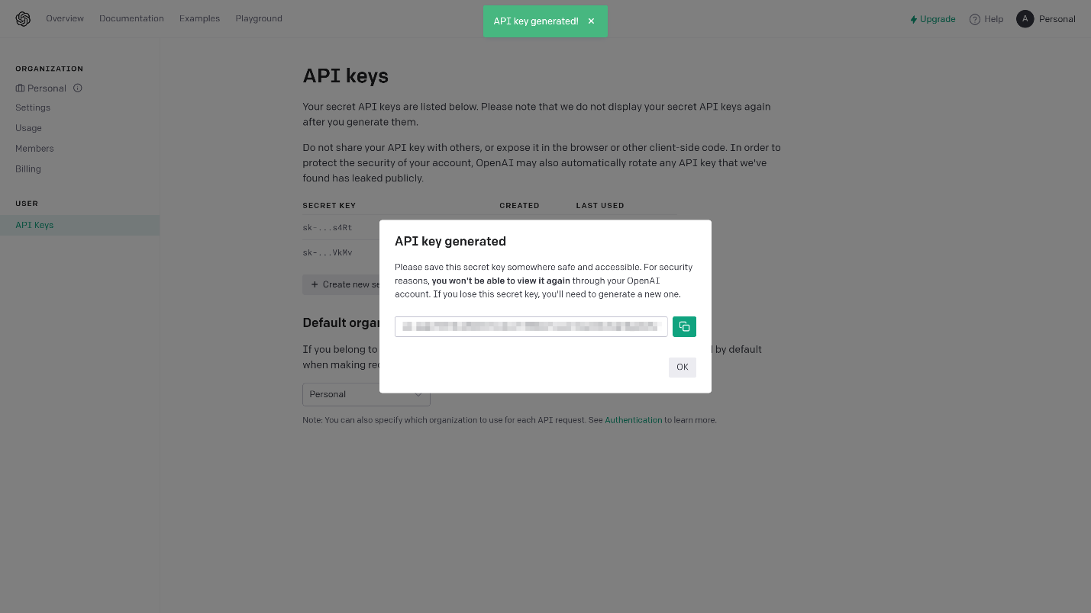

4. Put your key to Creatio system setting OpenAI Token
