Summary information
Summary information for the training session and scripts
Training Session | Learning how to use KeenQA
Creatio Product | Keen Survey Tool
Object(s) | Questionnaires and Interviews
Comments | Objective of this guide is for users to become familiar and comfortable with creating Questionnaires (which serve as a template) as the basis for Interviews (which are the answers or responses actually collected from a user)
Pre-requisites | For setting up questionnaires, users should be at the level of skill for a certified Creatio Analyst. For using questionnaires, users should be comfortable with standard Creatio functionality.

Script 1: Create a questionnaire
Step | Guidance
- Create a questionnaire | Navigate to the Questionnaire section and click the New button to create a questionnaire. The questionnaire functions as the template for the answers or responses that you will collect from system users. You’ll define questions and answers as to what the assessment, interview, survey, etc, should look like.
- View the Questionnaire | Open the record and view the different tabs and details below. This will be your first questionnaire.  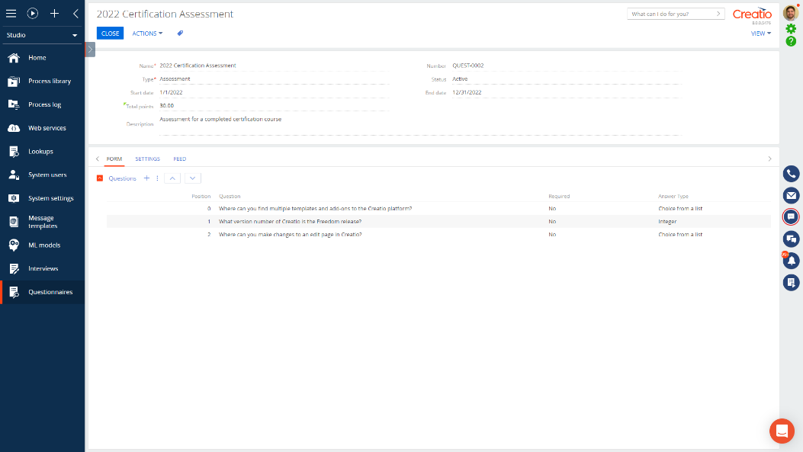
- Add a question | Click the plus button and add a question to the questionnaire. If the desired question is not listed, click the new button at the top of the window.  After you have chosen which question to add, a new page will open showing your chosen question and allowing you to select its type and correct answer(s).  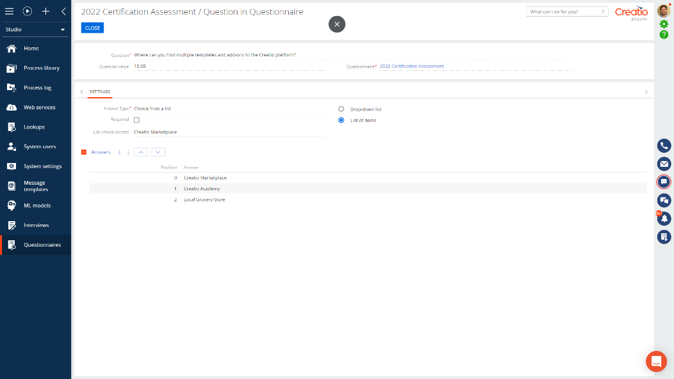  Chose which type of question you would like this question to be. As you change the type, the fields below will change prompting the corresponding types of correct answers.
- Define the correct answers | Once you have selected the type of question, be sure to fill it what is considered the correct answer or answers. Each type of question can have a correct answer for scoring once the interview is completed.  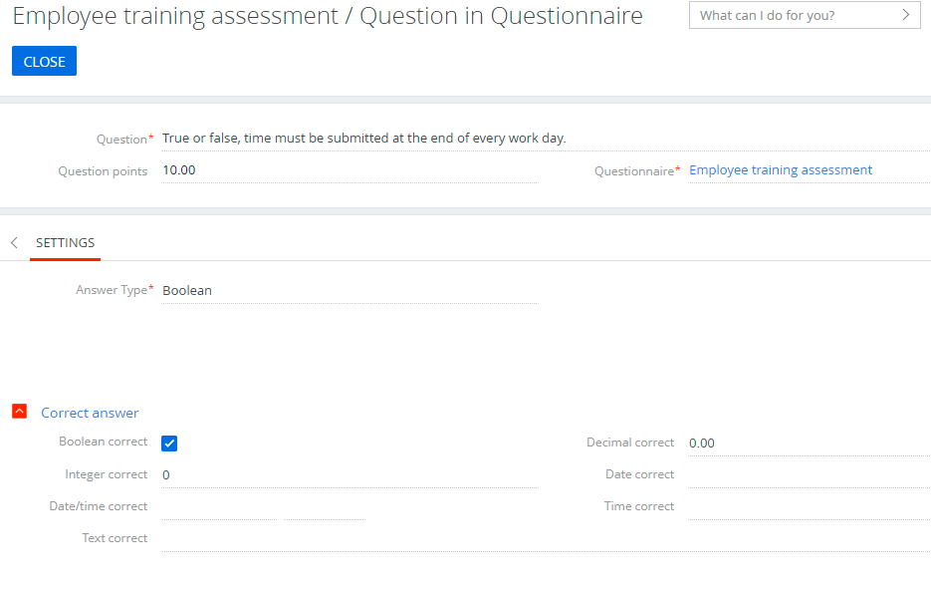
- Add scoring if necessary | Once you have chosen the correct answer for your question, fill in the Scoring field if scoring is needed for this questionnaire. You can add a total of available points to the question that will total up to a sum on the questionnaire for total possible points.  When you are done you can close the question. Add additional questions as needed.
- View scoring summary | Once all questions are added, you can view a summary of the connected questions, their point values and types on the scoring tab.
- Close | Close the record. You’ve created a questionnaire!

Script 2: Create an interview (by using and completing a questionnaire template)
Step | Guidance
- Create an interview | Navigate to the Interview section and click the New button to create a new interview record. Where the Questionnaire section provides the template, the Interview section creates an instance of the questionnaire being used and completed by a system user.
- View the Interview | Open the interview and view the fields  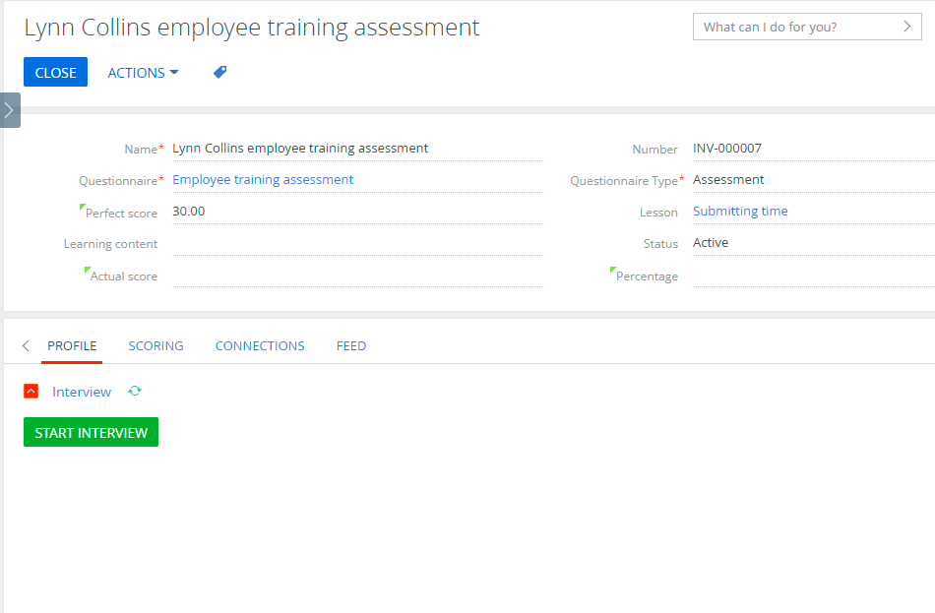
- Complete the interview | Click the Start Interview button to begin the interview. Fill out all questions, then click Complete Interview button to submit answers so that they can be scored (if relevant) and saved in the Creatio database.
- Review scoring | Once completed, the page should refresh as Creatio scores your answers. You can then navigate to the scoring tab to view which questions were answered correctly and incorrectly.  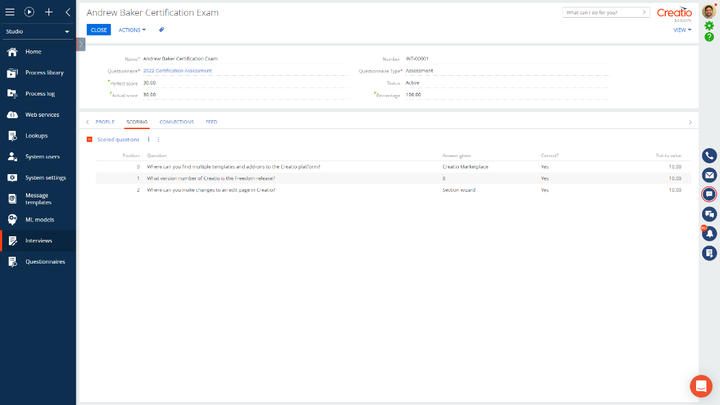
- Close | Close the record. You have completed an interview!

Script 3: View dashboards
Step | Guidance
- View Questionnaire Dashboards | 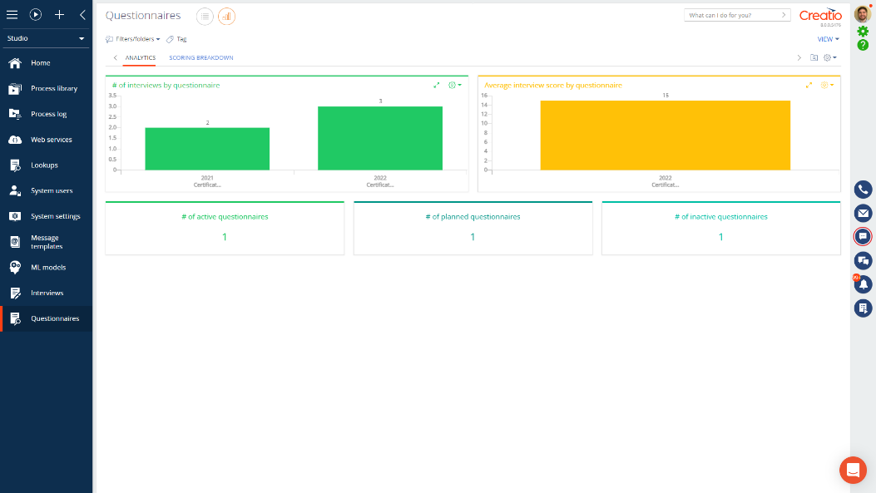
- View Interview Dashboards | 