Razorpay Payment Connector for Creatio
User Guide
AgilizTech
support@agiliztech.com

Contents
1 Razorpay Connector in Creatio - Sales 1
1.1 Overview 1
1.2 Business Use Case 1
1.3 Solution Benefits 1
2 Prerequisites 2
2.1 Guide For Using Utility 2
2.2 Update System Settings 2
2.3 Add Reference Code Mask ID in the Lookup 3
2.4 Create Razorpay Webhooks 3
3 Getting Started 7
3.1 Payment Status 7
3.2 Using Payment Option 7
3.3 Razorpay via Payment Link 11

Razorpay Connector in Creatio - Sales

Overview
The Razorpay payment connector integration into Creatio Sales CRM, facilitates seamless payment of invoices by connecting with Razorpay, enabling direct payment initiation and processing.

Business Use Case
Previously, payments occurred outside the system via invoicing, requiring manual updates by the sales team post the payment is made.
To enhance efficiency:
We've integrated a custom payment button with Razorpay.
Now, sales can click on the payment button and share the payment link via SMS and email.
Once the customer pays through the link, the invoice status automatically updates to "paid" eliminating manual intervention and simplifying the process.

Solution Benefits
The following points explain how the Razorpay payment plugin contributes to sales orders:
Providing customers with a direct payment link via SMS and email makes the process more convenient and seamless.
Customers can easily initiate payments, leading to quicker settlements and a positive experience.
Automating the payment status update eliminates the need for salesperson involvement, saving valuable time and resources.
The streamlined process reduces administrative tasks, allowing the sales team to focus on higher-value activities, ultimately boosting productivity.

Prerequisites

Guide For Using Utility
First, you need to install the plugin from the Creatio marketplace.
Once the Plugin is installed, you need to perform the make the following changes in Creatio.
Update System Settings
Add Reference Code Mask ID
Create Razorpay Webhook

Update System Settings
To update the System settings, do the following:
- Access the System Settings in your application.
- Use the search function within System Settings to find Razorpay Key ID.
The Razorpay Key ID page appears.
- In the Default value box, enter Live Razorpay Key ID, obtained from your Razorpay account.
- Similarly, use the search function to locate Razorpay Key Secret.
- Enter your Key Secret for Razorpay.
- Save the settings once you have provided both the Key ID and Secret.

Add Reference Code Mask ID in the Lookup
To add the reference code mask ID in the lookup, do the following:
- Navigate to the Lookups section.
- Search for Reference Code Mask: Use the Lookup search functionality to locate the Reference Code Mask.
- In the Code Mask box, replace the existing code mask with four alphabetical characters which will be used as reference ID while generating payment link.
- Click to save the code mask.

Create Razorpay Webhooks
You can use Razorpay Webhooks to configure and receive notifications when a specific event occurs. When one of these events is triggered, we send an HTTP POST payload in JSON to the webhook's configured URL.
Setting up the webhook connection between the Creatio instance and Razorpay:
- Navigate to the Contact section within your Creatio instance.
- Click Import and choose Web Forms and Pages.
The Web forms and pages page appears.
- Click Click to get your API Key.
The API key appears.
- Click to copy the API key.
Add this URL with your API key in the Razorpay Webhook URL box: https://webhooks.creatio.com/webhooks/{API_KEY}
- Navigate to https://dashboard.razorpay.com/.
- In the left pane, choose Account & Settings.
The Account and product settings page appears.
- In the Website and app settings section, choose Webhooks.
The Webhooks page appears.
- Click Add New Webhook.
The Webhook Setup page appears.
- In the Webhook URL , provide the webhook URL copied in step 4.
- In the Active Events section, select all four payment link options available under Payment_link Events:
- payment_link.paid
- payment_link.partially_paid
- payment_link.expired
- payment_link.cancelled
- Click Create Webhook to finalize the set up.
The webhook connection between Creatio and Razorpay is now set up.

Getting Started

Payment Status
Now, the following payment statuses are reflected in your invoice for the order you placed:
Canceled: The payment has been canceled and no money transferred.
Draft: The payment is still being made and has not been processed.
Paid: The full amount of the payment has been received.
Partially Paid: Only part of the payment has been received.
Unpaid: No payment has been received.

Using Payment Option
The Payment option is available only for the Invoices. There are two options to access the invoice, one from the Order and another Invoice section.
To request for the Payment from the existing Order
- In the Sales page, click Orders.
The Orders page appears.
- Open the required order for which you want to request PAYMENT.
The selected order page appears.
- Click the ORDER DETAILS tab.
- In the Invoice column, click the available Invoice link. For example, INV-6.
The Invoice page appears.
- Click the PAYMENT button to request payment.
A payment link will be sent to the customer both on their Mobile and Email Id. The screenshot below is an example of the email sent with payment link.
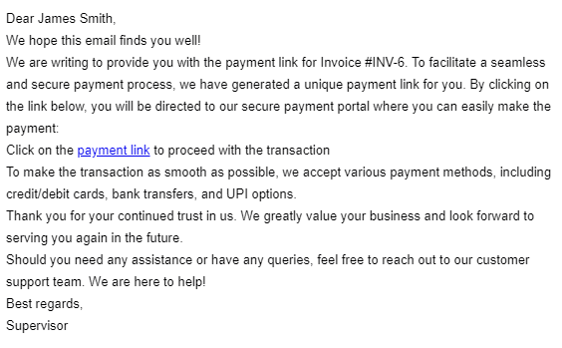
- The Payment link and Link Creation Date boxes appear with a payment link and creation date. Note: Refresh to see the link and date.
- Upon successful payment, the Paid on box is automatically updated with the payment date.

Razorpay via Payment Link
Once the Customer receives message via email or Text, they can click the Payment link and proceed with the payment.
How the payment link works for the Customer, here is an example of the email message with Payment link:
To proceed with the payment link
- In the message, click the payment link.
The Razorpay payment gateway page appears.
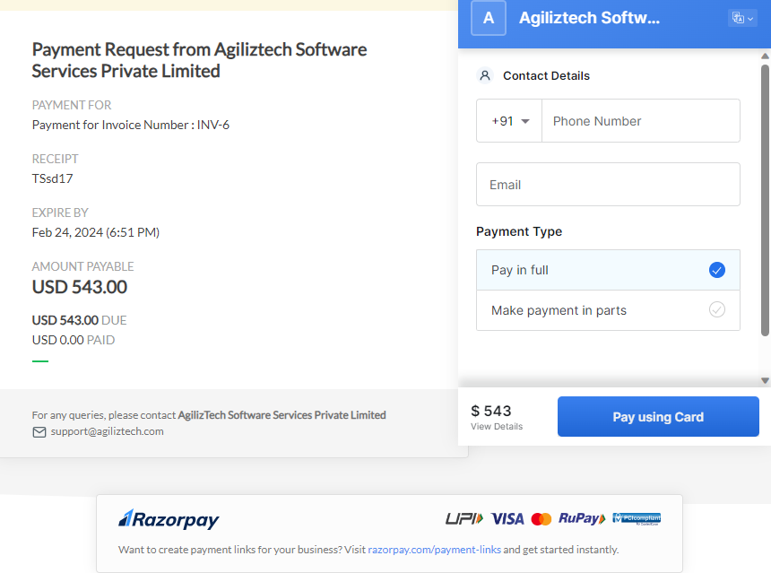
- Do the following:
  - In the Contact Details section, Type your phone number and Email address.
  - For the Payment Type, choose Pay in full or Make payment in parts option.
- Click Pay using Card.
The Pay Via Cards section appears.
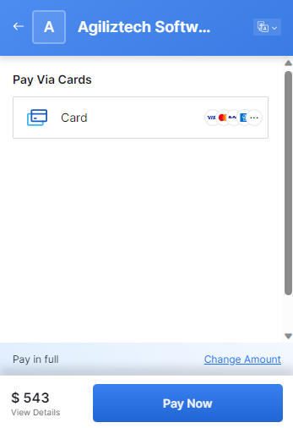
- Click Card.
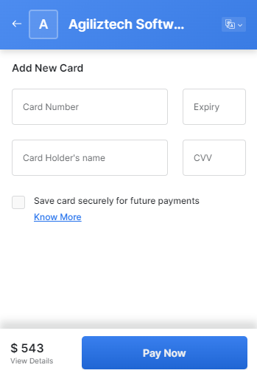
- Under Add New Card, enter your card details, and then click Pay Now.
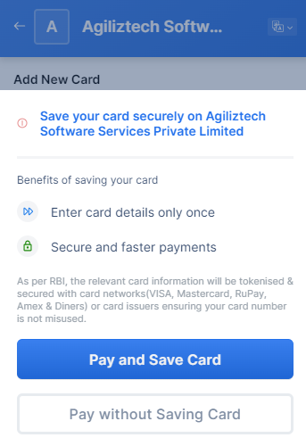
- If you want to save card details for the future transaction, click Pay and Save Card or else click Pay without Saving Card.
The ENTER OTP page appears.
- Enter the OTP and click Submit.
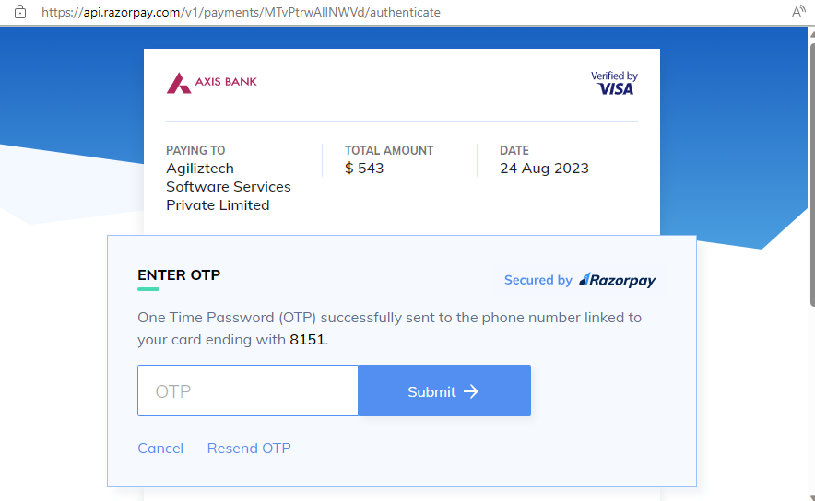
The Payment Completed page appears.
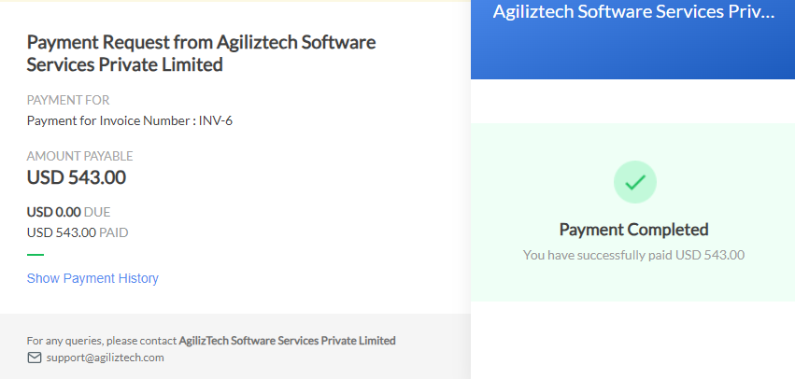
- Check the Invoice for which the payment was requested, it should have the payment details updated.

