User guide to application configuration

DData#HRMS Creatio

DData Consulting

Content
Systems LogIn 3
System settings management 4
Directory 9
How to add new levels of skills and scope of competence into the system 9
Adding onboarding status to the directory 10
Adding dismissal status to the directory 10

Systems Login
DData HRMS Creatio product is a web resource therefore follow the respective link to launch the system. SYSTEM LOGIN window will open. Login to the system using your personal Login and Password.

To log in:

- Enter the Login and Password in the appropriate fields:

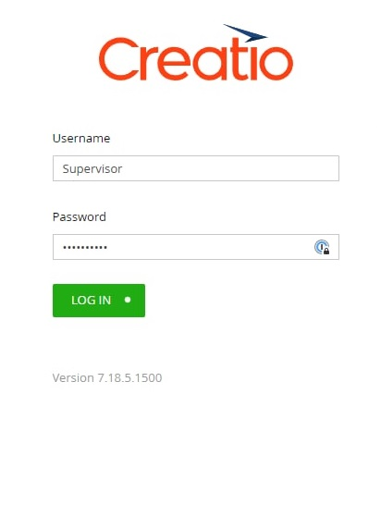

1. Click [Login].
Login to "DData HRMS" is completed.

System settings management
[System Settings] is used to further configure the system sections.

System settings allow to switch on/off the use of HRMS DDATA functionality during the work of employees. When enabled, HRMS DDATA functionality becomes mandatory.

List of HRMS functionality available for on/off switching:

• Use work schedules
• Use KPI
• Use Offboarding
• Use Onboarding
• Use skills and scope of competence
• Use functional responsibilities

System setting | Default setting | Description
Work schedule | On | The "Work schedule" field becomes mandatory for filling out in the following sections:  - Positions of employees  - Employees
KPI | On | The "KPI" detail is enabled for display and filling out in the following sections:  - Departments  - Employees
Offboarding | On | The "Offboarding" detail is enabled for display and filling out in the following sections:  - Employees
Onboarding | On | The "Onboarding" detail is enabled for display and filling out in the following sections:  - Employees
Skills and scope of competence | On | The "Skills" and "Scope of competence" detail is enabled for display and filling out in the following sections:  - Positions of employees  - Vacancies  - Interviews  - Contacts  - Employees
Functional responsibilities | On | The "Functional responsibilities" detail is enabled for display and filling out in the following sections:  - Departments  - Positions of employees  - Vacancies  - Interviews  - Contacts  - Employees

Default settings:

• Product version in use
• Country by default
• Mandatory indication of position and department

System setting | Options | Description
Product version in use | HRMS Full | Enables conducting interviews with candidates in the "Interviews" section
 | HRMS Lite | Enables conducting interviews with candidates in the "Contacts" section
Country by default | Ukraine | Used to calculate working days, to take into account weekends

To switch on/off HRMS DDATA functionality:

Note: Functionalities are enabled by default.
- Click the button in the upper left corner (it displays your current workplace)

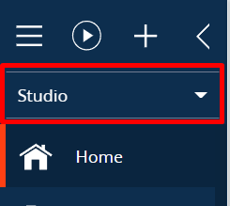

- Select the desired workplace from the drop-down list [Studio] and click
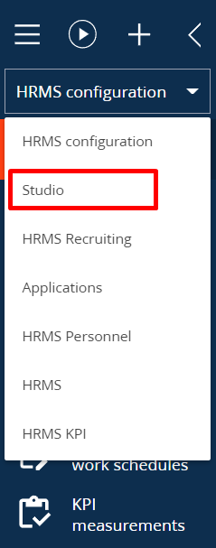

- Go to [System settings] section;
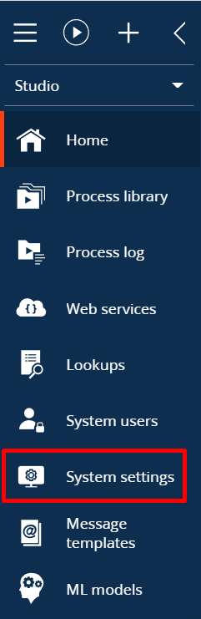
- Select Directory DDATA HRMS;
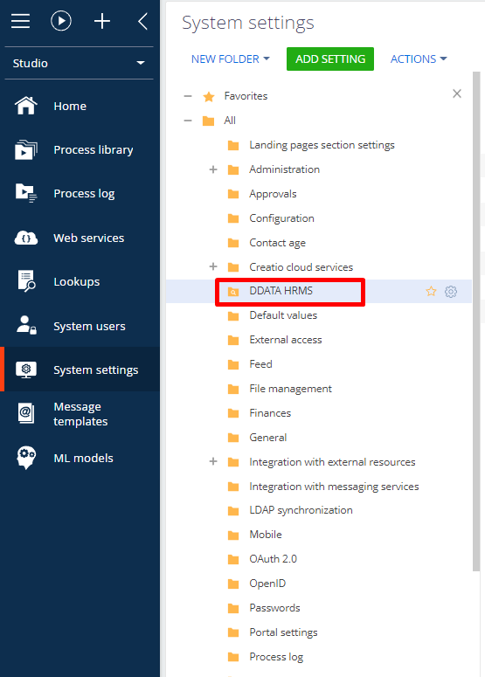

- Select the necessary functionality from the list and click [Open];

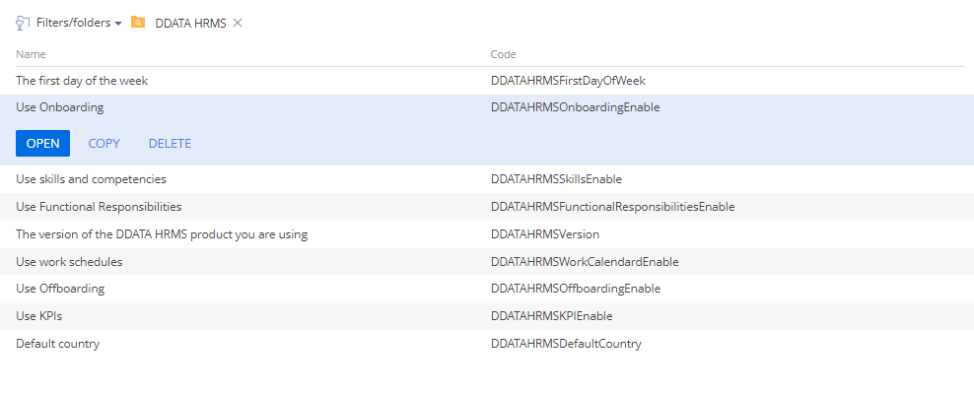
- Tick the checkbox [Use by default] to enable the functionality or remove the tick to disable the functionality.

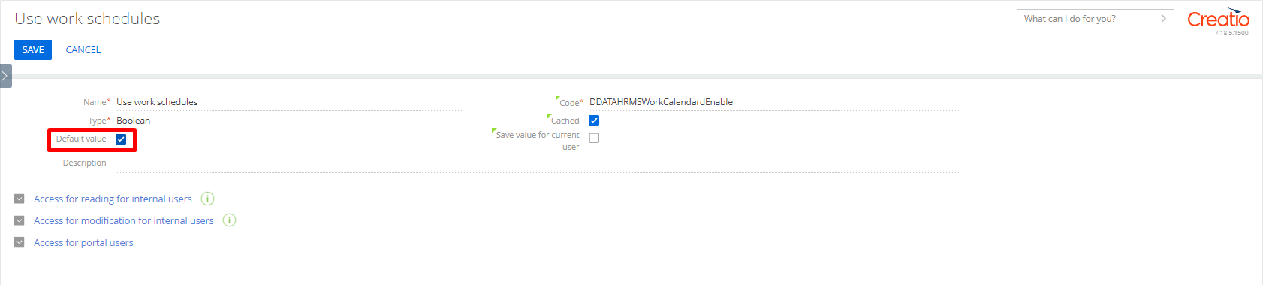
- Click the [Save].

To open [System settings] from any section, press the in the upper right corner of the application and select [Open system designer] - [System configuration] - [System settings].

Directory
The system has pre-configured directory. Only users with system administrator or HRMS manager roles are provided with an access to reference books.
How to add new levels of skills and scope of competence to the system
Follow the steps below to add new levels of skills and scope of competence to the system:
- Open the workplace [Studio]
- Go to section [Directories]
- In the dynamic group [HRMS], find and open the directory [Employee skills levels]
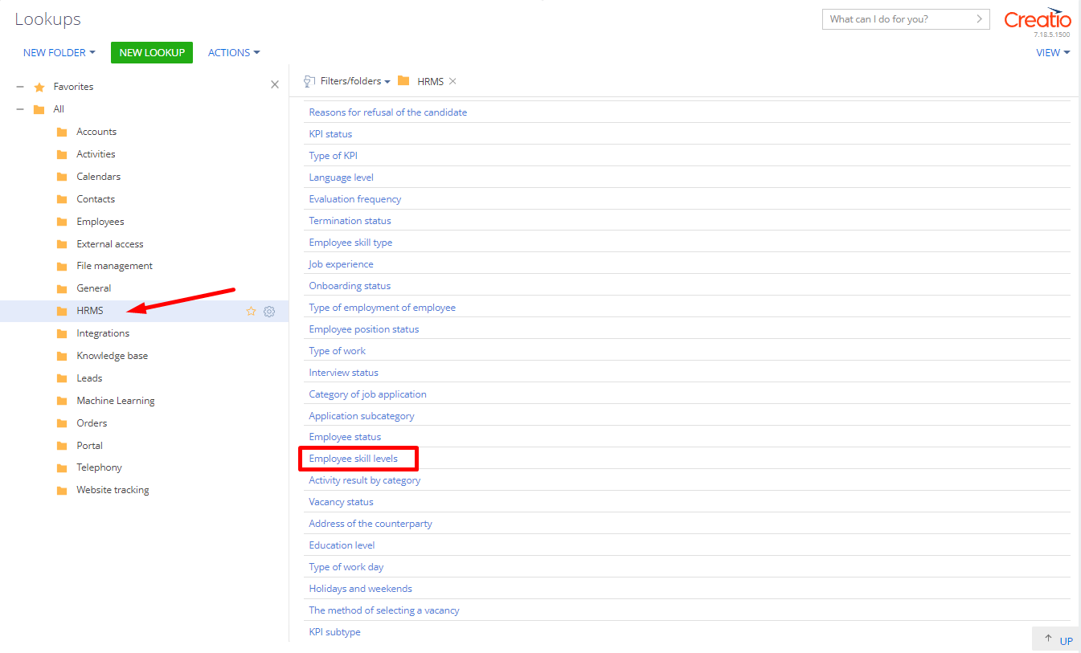
- Click [Add]
- Fill in the following fields that appear:
• [Title]
• [Skill Type] click to open the drop-down list
• [Points]
• [Default] to set the default level
Important
A skill and competence level marked with [Use by default] will be automatically set for skills and scope of competence added to a vacancy.
- Click to save the entry of the employee's new skill level

Adding Onboarding status to the directory
Follow the steps below to add new onboarding status to the system:
- Open workplace [Studio]
- Go to section [Directories]
- In folder [HRMS], find and open directory [Onboarding status]
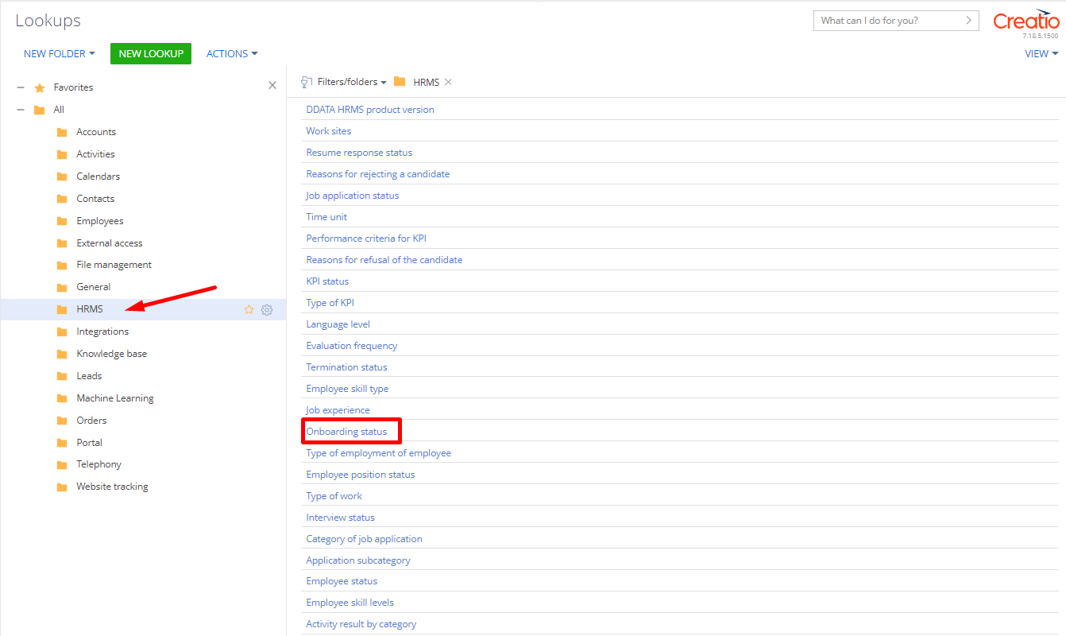
- Click [Add]
- Fill in the required fields:
• [Title]
• [Calendar days]
- If necessary, fill in the optional fields:

• [Description]

• [Negative]
- Click to save the entry of the employee's new onboarding status
Adding Dismissal status to directory
Follow the steps below to add new dismissal status to the system:
1. Open workplace [Studio]
2. Go to section [Directory]
3. Go to folder [HRMS], find and open directory [Dismissal status]
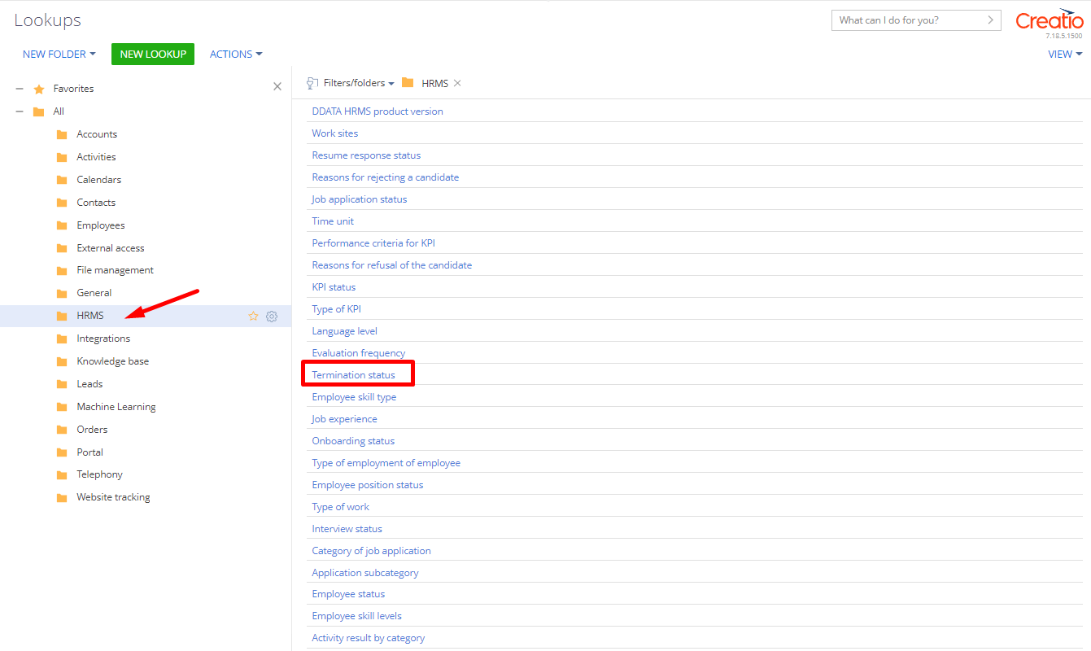
- Click [Add]
- Fill in the required fields:
• [Title]
• [Calendar days]
- If necessary, fill in the optional fields:
• [Description]
• [Negative]
- Click to save the entry of the employee's new dismissal status

